AGREEMENT BETWEEN
THE BOARD OF DIRECTORS OF THE PALMDALE AEROSPACE ACADEMY
AND
THE PALMDALE CLASSIFIED ASSOCIATION
May 27, 2025 through June 30, 2027


TABLE OF CONTENTS
Page
Article I Agreement 1
Article II RECOGNITION 2
Article III Association Rights 3
Article IV Management Rights 7
Article V Organizational Security 8
Article VI Employment Status 9
Article VII Employee Discipline/Dismissal 10
Article VIII GRIEVANCE PROCEDURE 16
Article IX Compensation 20
Article X Health & Welfare 23
Article XI Leaves of Absence 26
Article XII Work Year & Hours of Employment 34
Article XIII Transfers & Reassignments 36
Article XIV Evaluation 39
Article XV Professional Growth & Development 42
Article XVI Safety 43
Article XVII Personnel Files 47
Article XVIII Holidays 49
Article XIX Layoff 51
Article XX Uniforms and Dress Code 56
Article XXI Vacation 58
Article XXII Severability 60
Article XXIII Statutory Changes 61
Article XXIV Assignability 62
Article XXV Publication 63
Article XXVI Renegotiation 64
Article XXVII Entire Agreement 65

- Agreement
Agreement

  - This Collective Bargaining Agreement (hereafter referred to as “Agreement”) made and entered into May 27, 2025, constitutes a bilateral and binding agreement between the Board of Directors of The Palmdale Aerospace Academy (hereafter referred to as the “TPAA” or “Academy”) and the Palmdale Aerospace Classified Association/CTA/NEA (hereafter referred to as the “Association” or “PACA”), and employee organization. This Agreement is entered into pursuant to Chapter 10.7, Section 3540-3549 of the Government Code (hereafter referred to as the Educational Employment Relations Act, or “EERA”) and it shall be in full force and effect until June 30, 2027.
  - During the 2024-2025 negotiations cycle, either party reserves the right to present future articles which may have a retroactive effect date to July 1, 2024.

- RECOGNITION
  - The Palmdale Aerospace Academy (“TPAA” or “Academy”) recognizes the Palmdale Aerospace Classified Association (“PACA” or “Association”) as the exclusive representative pursuant to the Educational Employment Relations Act (EERA). (Government Code Section 3540, et seq.) for all full-time and regular part-time classified personnel. All other employees shall be excluded including management, supervisory, and confidential employees within the meaning of EERA section 3540.1. The bargaining unit of classified personnel at the Academy shall be known as the Palmdale Aerospace Classified Association (“PACA”).
    - A list of classified classifications shall be listed in APPENDIX A
    - Classified unit positions shall not include short-term employees, substitute employees, or volunteers.
  - Any new school site(s), campus of the Academy or expansion of the Academy approved by the chartering authority pursuant to a material revision shall be covered under this collective bargaining agreement.
  - The parties to this Agreement recognize that the duties and work performed by the bargaining unit, as described in 2.1 above, shall be performed only by unit members, except as delineated herein.
    - Any decision to contract out classified work will be made in accordance with the terms of this Agreement.
    - If an emergency situation arises that threatens to halt the Academy’s operations and/or the safety of Academy sites, the Academy shall notify PACA of its immediate need to contract out. Should contracting out proceed under this provision, it shall be on a one time basis and non-precedent setting. The Academy shall redirect work to bargaining unit members, as appropriate, once the need to contract out is over.
    - If a situation arises where it is not feasible for bargaining unit members to perform classified unit member work due to an unfulfilled vacancy, lack of technical skill(s), certifications, and/or the scope of the project, the Academy shall provide PACA written notice of its need to contract out and an opportunity to negotiate the impacts and effects of the decision to contract out. The Academy shall redirect work to bargaining unit members, as appropriate, once the need to contract out is over.
    - The parties recognize that nothing in this Article shall prevent the utilization of day-to-day substitutes for temporary and appropriate coverage of unit members.
- Association Rights
  - The Association has the right under the Educational Employment Relations Act to represent unit members in their employment relations with the Academy. Nothing in this Agreement shall be construed as a waiver of such rights.
Communication
  - The Association shall have the right to post notices of activities and matters of Association concern on an Association bulletin board at the elementary and secondary school site and in an area frequented by bargaining unit members. Designation of the bulletin board shall be by mutual consent of the Association representative and the site administrator.
  - The Association shall have the right to use Academy mail services/electronic mail (“E-mail”) and unit member mailboxes/E-Mail to communicate with unit members concerning Association business. It shall be the responsibility of the Association to place its communication in the appropriate mailboxes/E-mail. Emails and/or distribution of communication regarding Association business shall occur during non-duty hours.
    - A courtesy copy of any communication distributed or posted sitewide pursuant to this Article will be provided concurrently to site administration.
    - Such materials placed in the Academy mail service/E-mail and unit members mailboxes/E-mails shall be dated, signed by an official of the Association, and have the name of the Association.
    - The Association shall have an electronic mailbox in the Academy’s electronic mail system.
    - The Academy acknowledges the right of the Association to communicate with its members. The Association agrees that all communication shall adhere to standards of professionalism and respect for all parties involved.
    - Unit members shall have the right to access private E-mail accounts from Academy computers.
  - The Association shall have a single mailbox available at the elementary and secondary sites for communication between the unit members and the Association.
  - The Association and its members shall have the right to use school facilities and equipment for Association business at reasonable times and places as approved by the site and/or Academy administrator. Appropriate forms shall be completed by the requester. Such use shall not interfere with the educational process and shall not conflict with other scheduled meetings.
  - The authorized representative(s) of the Association may transact official Association business on school property at all reasonable times. Reasonable times shall mean: before the start of the work day, after completion of the work day, lunch period, and periods during which an employee is present at the school site, but not expected to perform services for the Academy. The Association representatives, when entering a school site for official Association business, shall promptly identify themselves at the school office and obtain authorization from the site administrator or designee, whose authorization shall not be unreasonably withheld, prior to coming on campus and contacting any Academy employee. The Association further agrees that the Association representatives in exercising the right of access to employees shall not disturb, disrupt, or otherwise interfere with the work of any employee of the Academy.
Release Time
  - The president of the Association shall be released from their regularly assigned duties once a month with no loss of salary or other benefits to conduct Association Business.
  - The Association shall have a combined total of fifteen (15) days annually of paid leave for its representatives to utilize for Association Business. Written notification shall be sent to the Academy Office not less than five (5) work days prior to the date of the absence. Release time will be subject to prior written approval of the Superintendent or designee when the release times include multiple association unit members and/or multiple consecutive days of release. Approval will not be unreasonably withheld. Upon request, the reason for denial of release time will be provided in writing.
  - Association representatives shall have the right to receive reasonable periods of released time without loss of compensation when meeting and negotiating and for the processing of grievances. In the event a unit member requests Association representation in investigatory and/or disciplinary meetings, the Association representation will not suffer loss of pay or benefits.
  - Unit members who work evening shifts shall normally be permitted time off to attend one (1) Association meeting per month. Unit members must clock out during time attending Association meeting(s). The length of time away from the work site shall not exceed two (2) hours and this time shall be made up by extending that particular shift by the total number of minutes the unit member absented themselves from the work site. It shall be the responsibility of the unit member to inform their immediate supervisor, at least five (5) work days in advance, should they elect to attend an Association Meeting. The Association President shall inform the Superintendent or designee if additional time is needed for a particular meeting or additional meeting(s); additional time off may be granted upon mutual agreement.
New Bargaining Unit Member Orientation
  - “New employee orientation” means the onboarding process of a newly hired public employee, whether in person, online, or through other means or mediums, in which employees are advised of their employment status, rights, benefits, duties and responsibilities, and other employment-related matters.
  - If the Academy provides an orientation for a newly hired bargaining unit member, new bargaining unit members shall be paid their hourly rate for the duration of the required orientation meeting when orientation occurs outside the contract year and/or day. The Academy shall provide the Association access to its new employee orientation(s).
Scheduling of Orientation
  - The Association shall receive no less than ten (10) work days’ notice of an orientation. A shorter notice may be given in a specific instance where there is an urgent need critical to the Academy’s operations that was not reasonably foreseeable.
  - If an orientation is scheduled with new bargaining unit members hired after the start of the school year, the Association shall be provided advance notice of the meeting time, date, and location. The Academy shall provide no more than one (1) hour of paid release time, free from regular duties, for an Association representative to meet with the new bargaining unit member.
  - For orientation/onboarding meetings after the start of the school year, the Academy shall provide the newly hired bargaining unit members with the Association's Welcome Packet. All resources and costs for the Welcome Packet shall be incurred by the Association. If the Academy anticipates not having enough Welcome Packets, the Academy shall notify the Association President or designee.
Association Time Provided
  - If the Academy provides an orientation before the start of the school year, the Association shall be provided one (1) hour of uninterrupted time, at the end of the scheduled orientation, to communicate with bargaining unit members at the new bargaining unit member orientation meeting(s). Administrators will excuse themselves during Association time, unless invited to attend.
  - The Association is entitled to invite California Teachers Association (CTA) staff and endorsed vendors to the Association portion of new bargaining unit member orientation meeting(s) and will have access to Academy audio visual equipment for Association presentations.
Bargaining Unit Member Information
  - “Newly hired employee” or “new hire” means an employee, whether permanent, full time, part time, hired by the Academy, and who is still employed as of the date of the new employee orientation.
  - If on file with the Academy, the following information for all bargaining unit members shall be delivered to the Association President or designee in a mutually agreed upon digital format by the last working day of September, January, and May. In addition this information shall be delivered to the Association within thirty (30) days of hire or by the first pay period of the month for new hires whichever comes first:
a. Full Name - first, last, and middle initial (if provided)
b. Home Address
c. Work location
d. Personal (non-Academy) Email Addresses
e. Phone Numbers – work, home and cellular
f. Job title
g. Department

  - This information will be provided to the Association regardless of whether the newly hired employee was previously employed by the Academy.
Time on Professional Development Day
  - Upon request and with at least five (5) working days advance notice, the Association shall be entitled to sixty (60) uninterrupted minutes during each Professional Development day to communicate with bargaining unit members. This Association time shall be for bargaining unit members only. Administrators will excuse themselves during Association time. The Academy will make a good faith effort to collaborate with Association leadership to determine the most appropriate time for the Association to conduct its sixty (60) minute meeting.
  - Unit members must clock out during time attending Association meetings during Professional Development days. The length of time away from the work site shall not exceed sixty (60) minutes and this time shall be made up by extending that particular shift by the total number of minutes the unit member absented themselves from the work site. It shall be the responsibility of the unit member to inform their immediate supervisor, at least five (5) work days in advance, should they elect to attend an Association Meeting. The Association President shall inform the Superintendent or designee if additional time is needed for a particular meeting or additional meeting(s); additional time off may be granted upon mutual agreement.
- Management Rights
  - It is understood and agreed that except as modified, abridged, and/or waived by this Agreement, The Palmdale Aerospace Academy shall retain all of its rights and abilities to direct, manage, and control its operations to the full extent of the law, subject to the terms of this Agreement and the Academy’s charter, including but not limited to the following:
    - Determining the legal, operational, governance, and organizational structure of the Academy;
    - Determining the mission, intention and overall program design as described in the school’s charter;
    - Determining the staffing plans and allocation, including but not limited to hiring or layoff;
    - Establishing the financial structure of the Academy including investment policies and practices, budgeting procedures and budgetary allocations, reserves and expenditures;
    - Determining the methods of raising revenue; and
    - Taking action on any matter in the event of an emergency, as permitted by the law.
  - The exercise of the foregoing rights, the adoption of policies, rules, regulations, and practices in the furtherance thereof, and the use of judgment and discretion in connection therewith, shall be limited only by the specific and express terms of this Agreement consistent with and limited by law and the Academy’s charter.
  - The Palmdale Aerospace Academy recognizes its duty to negotiate with the Palmdale Aerospace Classified Association over the impact on mandatory subjects of bargaining under Government Code section 3543.2.
  - Since this Article is not a source of the Palmdale Aerospace Classified Association or Employee Rights, it is not subject to grievance.

- Organizational Security
  - PACA/CTA/NEA shall deliver to the Academy an assignment authorizing deduction of unified membership dues, initiation fees and general assessments in the Association. Pursuant to such authorization, the Academy shall deduct one-tenth (1/10th) of such dues from the regular salary check of the unit member each month for ten (10) months. Deductions for unit members who sign such authorization after the commencement of the school year shall be appropriately prorated to complete payments by the end of the school year.
  - With respect to all sums deducted by the Academy pursuant to this Article, for membership dues, the Academy agrees to promptly remit, but no later than the fifteenth (15th) of each month, such monies to the Association, accompanied by a list of unit members for whom such deductions have been made.
  - The Association agrees to furnish the Academy with a membership roster to fulfill the provisions of this Article. The Association shall not be required to submit to the Academy copies of an individual unit member’s written authorization unless a dispute arises about the existence or terms of the written authorization.
  - Unit members paying their Association dues by cash directly to the Association shall have their cash dues or fees paid by October 1 of each subsequent year after initial enrollment.
  - The Association agrees to defend and indemnify the Academy for any claims made by unit members for deductions made in reliance on the membership list provided by the Association.
  - The Association shall have the exclusive rights to decide and determine whether any such actions or proceeding referred to above shall or shall not be compromised, resisted, defended, tried, or appealed.
  - The written authorization for payroll deduction of unit members shall remain in effect until expressly revoked in writing by the unit member, pursuant to the terms and conditions of the written authorization.
  - Unit member requests to cancel or change authorizations for payroll deductions for members in the PACA/CTA/NEA shall be directed to the Association President.
  - The Association is responsible for processing requests to cancel or change authorizations for payroll deductions or unit members’ membership status in the PACA/CTA/NEA.
  - The Academy shall rely on information provided by the Association regarding whether unified dues payroll deductions were properly canceled or changed.
- Employment Status
Probationary Period

  - During the first one hundred thirty (130) days of paid service with the Academy, bargaining unit members shall be employed in a probationary status.
Release During Probationary Period
  - During the probationary period, the unit member may be released from employment without cause.
Probationary Period During Implementation of First Contract
  - At such time when the initial collective bargaining agreement is fully ratified, unit members shall be given credit for previous service toward completion of the probationary period as defined in Section 6.1.
Completion of Probationary Period
  - Upon completion of the probationary period, unit members shall be classified as permanent and shall only be disciplined and/or discharged in accordance with Article VII, Employee Discipline/Dismissal.
Promotion
  - Unit members who are promoted shall serve a three (3) month probationary period in the new classification or position.
  - Promoted unit members who do not successfully pass the three (3) month probationary period in the promoted position shall be returned to their former classification or position provided their previous classification or position remains vacant. If the unit member’s previous classification or position is no longer vacant, then the unit member will be provided a comparable position at the discretion of the Academy.

- Employee Discipline/Dismissal

Discipline or Dismissal for Just Cause
  - Subject to the limitations specified in the Article in this Agreement entitled, “Employment Status,” no unit member shall be disciplined, dismissed, reduced in rank or compensation without just cause. Discipline of a unit member shall be done pursuant to the procedures set forth in this article.

Definition of Discipline
  - Disciplinary action includes any action taken by the Academy against a Permanent unit member, including, but not limited to, a suspension, demotion, dismissal, or any other punitive action which causes a reduction in pay without the unit member’s voluntary written consent, except a layoff for lack of work or lack of funds.

Investigation and Disciplinary Meetings
  - If the Academy deems an investigation is warranted, as part of its investigation, the unit member accused of misconduct shall be provided an opportunity to meet with the administrator or designee investigating the alleged misconduct.
  - When an administrator seeks a conference with a unit member where it is evident that the unit member is the focus of possible disciplinary action, the unit member shall be notified of the purpose of the meeting before the meeting takes place and that it is the unit member’s right to be accompanied and represented by an association representative(s). Such rights and obligations shall be consistent with all legal requirements.
  - A unit member has the right to request and receive union representation during any meeting that could reasonably lead to disciplinary action.

Progressive Discipline
  - Except in cases of serious or egregious conduct, discipline shall be consistent with the principles of progressive discipline as specified herein.
  - Progressive discipline is intended to correct unit member misconduct and resolve performance issues at the earliest and least severe stages of discipline. Supervisors will make reasonable efforts to utilize verbal warnings, written warnings/reprimands, and performance improvement plans before utilizing more severe forms of discipline such as suspension, demotion, and dismissal. As such, all disciplinary action shall include specific recommendations and may include professional support to correct the misconduct.

Causes for Disciplinary Action
  - The following independently or collectively are causes for discipline:
    - Unsatisfactory Performance
    - Insubordination or willful defiance
    - Using or possessing firearms, weapons, or explosives of any kind on Academy premises. This may also include any look-a-like firearms, weapons, or explosives.
    - The sale of alcohol or drugs on Academy property; the possession of alcohol or controlled substances on Academy property (unless such substances are supported by a valid prescription).
    - Appearing for work under the effects of alcohol or using alcohol or drugs illegally while on duty.
    - Appearing for work under the effects of drugs or medications that impair the ability to perform job duties effectively or result in an unsafe condition.
    - Being convicted by a court of competent jurisdiction of a felony or a crime involving moral turpitude, including violations of Education Code sections 44010 or 44011.
    - Engaging in political activities during assigned hours of duty.
    - Discourteous, abusive, or threatening treatment of the public, employees, or students including but not limited to, ethnic, racial, or religious hate speech.
    - Repeated, unexcused absence or tardiness; abuse of leave privileges; absence without notification or; absence without leave.
    - Dishonesty, theft, willful misuse for personal gain, willful destruction or mishandling of Academy property.
    - Failure to disclose material facts or the making of any false or misleading statement on any application, examination form, or other official document(s) of the Academy.
    - Violations of the sexual harassment policy.
    - Advocacy of the overthrow of the federal, state, or local government by force, violence, or other unlawful means.
    - Offering anything of value or offering any service in exchange for special treatment in connection with the unit member's job or employment, or the accepting of anything of value or any service in exchange for granting any special treatment to another employee or any member of the public.
    - Revocation, suspension or expiration of any license which is required for any unit member’s job duties.

Progressive Discipline Steps

Notification
  - Prior to issuing any of the progressive discipline measures, the unit member accused of misconduct shall be provided an opportunity to meet with the administrator investigating the alleged misconduct.
  - If an administrator is investigating alleged misconduct and schedules a meeting with a unit member, the unit member shall be provided the reason for the meeting prior to the meeting’s beginning.

Verbal Counseling/Warning
  - The Academy may choose to first issue a verbal warning regarding a unit member’s performance or behavior issues before imposing further discipline. A verbal warning will be provided to the unit member by their immediate supervisor or designee. A verbal warning may be reduced in writing to a post-conference summary memorandum.

Written Warning/Reprimand
  - The Academy may issue a written warning/reprimand regarding a unit member’s performance or behavior issues before imposing further discipline. The unit member may sign the reprimand to acknowledge receipt before a copy is placed in a unit member’s personnel file. Should the unit member decide to submit a written response, the written response will be included along with the written warning/reprimand in the unit member’s personnel file.
  - The Academy may provide mentorship or training in an area of concern noted in the written warning/reprimand.

Suspension Without Pay
  - Subject to 7.6 above, suspension will not be used unless the unit member has received a written reprimand about similar actions. Suspensions without pay may be implemented for up to seven (7) workdays.

Demotion
  - Demotion of a Permanent Employee shall be limited to within the same classification to which the employee belongs to at the time of the Recommendation.

Dismissal
  - Dismissal shall be carried out in accordance with this Article.

Suspension
  - Notice of Recommended Suspension will be made in writing and served in person or by certified mail upon the unit member by the Director of Human Resources or designee prior to imposing a suspension without pay. Upon request, a copy will be concurrently provided to the Association President. The Recommendation will contain:
    - A statement of the specific act(s) or omission(s) upon which the action is based;
    - A statement of the cause(s) for which action is recommended;
    - Where applicable, the policy, rule, regulation, or directive violated;
    - The penalty proposed and effective date;
    - Copies of the documentary evidence upon which the recommendation is based;
    - Notice of the unit member’s right to challenge the proposed action by appealing the decision to the Board.
    - If timely appealed, the penalty will not be applied until the Board’s decision is rendered, except for just cause necessitating the immediate removal of the unit member from the worksite. At the suspension hearing, the just cause for earlier discipline may be determined by the Board. If a suspension action is appealed to the Board, the Board’s decision on the suspension action is final.
    - The unit member must appeal the proposed action by delivering written notice of appeal to the Superintendent or designees within ten (10) working days after receipt of the notice of suspension via certified US mail, email, or personal service. If the unit member does not demand a hearing within the above timeline, suspension may be imposed immediately by the Superintendent or designee.

Demotion or Dismissal Process
  - Notice of Recommended Demotion or Dismissal will be made in writing and served in person or by certified mail upon the unit member by the Director of Human Resources or designee prior to imposing a suspension without pay or dismissal from employment. Upon request, a copy will be concurrently provided to the Association President. The Recommendation will contain:
    - A statement of the specific act(s) or omission(s) upon which the action is based;
    - A statement of the cause(s) for which action is recommended;
    - Where applicable, the policy, rule, regulation, or directive violated;
    - The penalty proposed and effective date;
    - Copies of the documentary evidence upon which the recommendation is based;
    - Notice of Appeal Rights. The Academy will notify the unit member of their right to challenge the proposed disciplinary action. Administration shall not advise or place pressure on the unit member regarding which option to choose. The unit member may select one of the following options:
      - Request Advisory Arbitration - The employee may appeal the decision through advisory arbitration, provided the Association approves the unit member’s request. In this case, the Association will share the cost of the arbitrator equally with the Academy.
      - Direct Appeal to the Board - The unit member may appeal the proposed discipline directly to the Board, without proceeding through advisory arbitration.
    - If timely appealed, the penalty will not be applied until the Board’s decision is rendered, except for just cause necessitating the immediate removal of the unit member from the worksite. At the demotion or dismissal hearing before an arbitrator, the just cause for earlier discipline may be determined by the arbitrator. The arbitrator will make a recommendation to the Board. The Board may accept, reject, or modify the recommendation. The Board’s decision will be final.

If the unit member appeals directly to the Board, the Board will decide whether there is just cause for the discipline. The Board’s decision will be final.
    - The Association must appeal the proposed action by delivering written notice of appeal to the Superintendent or designees within ten (10) working days after receipt of the notice of demotion or dismissal via certified US mail, email, or personal service. If the unit member does not demand a hearing within the above timeline, the demotion or dismissal may be imposed immediately by the Superintendent or designee.

Time Limits On Disciplinary Action
  - Disciplinary action shall not be taken against a unit member for any cause which arose prior to the unit member earning Permanent employment, nor for any cause which arose more than two (2) years prior to the date of the Notice of Proposed Disciplinary Action, unless such cause was concealed or not known to the Academy within the two (2) year period.

Administrative Leaves
  - In the event a unit member is placed on administrative leave without advance notice, a notice conforming to the specifications set forth above will be given in person as well as sent to the unit member by certified mail addressed to the unit member's last known address, within five (5) days of the unit member's removal from the position.
  - While on paid administrative leave, unit members will be relieved of their regular assignment and are to refrain from being on Academy property unless directed to attend a meeting by Human Resources. All Academy provided items (i.e. keys, keycards, technology devices, etc.) shall be returned to the Human Resources office upon notification of administrative leave. While on paid administrative leave, unit members will continue to receive their regular pay and benefits.

Confidentiality
  - When giving reprimands, warnings, or criticism, privacy appropriate to the professional relationship shall be maintained.
  - All information or proceedings regarding any actions or proposed actions pursuant to the Article will be kept confidential by the parties to the extent permitted by the law.

Exclusion
  - This Article shall not prohibit the Academy from placing a unit member on an improvement plan.

- GRIEVANCE PROCEDURE
Definitions

  - A "grievance" is a violation, misinterpretation or misapplication of a provision of this Agreement.
  - The "grievant" is the unit member, unit members, or the Association making the claim.
  - A “day” is a day in which the unit member(s) is(are) scheduled to work as set forth in this Agreement.
  - “Academy Grievance Form” shall mean an Academy provided form which shall be completed in writing. (APPENDIX B. Grievance Form)
  - “Presenting and Processing” grievances shall mean the discussion, written statements and responses between the grievant and the immediate supervisor involved in each step of the process.
General Provisions
Purpose
  - The purpose of this procedure is to secure, at the lowest possible administrative level, equitable solutions to the problems that may arise concerning the provisions of this Agreement.
  - Both parties agree that these proceedings will be confidential.
Time Limit
  - Since it is important that grievances be processed as rapidly as possible, the time table specified at each level hereafter should be considered as a maximum and every effort should be made to expedite the process. The time limits may, however, be extended in writing by mutual agreement of the grievant and the Academy. The failure of the Academy to respond to a grievance at any step within the required time frame shall result in an automatic appeal of the grievance to the next step. The failure of the grievant(s) to appeal the decision to the next Level within the required time frame shall result in the grievant(s) losing the contractual right to continue the grievance under the terms of this Article.
Rights of Representation
  - A grievant may be represented at all stages of the grievance by an Association representative(s) or Association appointed legal representative.

Miscellaneous
  - Grievances which arise as a result of an Academy action(s) or decision(s) that occur at a level higher than the immediate supervisor or designee may be filed at Level Two.
  - Once a grievance has been filed, the investigation and processing of grievances and arbitrations, to the greatest extent possible, will be accomplished during the normal workday. When it is necessary for a representative(s) designated by the Association to attend a grievance meeting or hearing during the day, they shall be released without loss of pay in order to permit participation in the foregoing activities. Any unit member who is requested to appear in such investigations, meetings, or hearings as a witness will be accorded the same right.
  - Nothing contained herein shall be construed as limiting the right of any employee in the bargaining unit, having a grievance, to discuss the matter with the principal or their designee and to have the grievance adjusted without the intervention of the Association, provided that adjustment reached prior to arbitration is not inconsistent with this Agreement.
Procedure
Informal Conference (Collaborative Level)
  - An attempt may be made to resolve the grievance by an informal conference between the unit member, if the unit member desires to be present, and an Association representative(s), if the unit member so desires such representation, and the immediate supervisor. This informal conference shall take place within thirty (30) days of the alleged occurrence or omission giving rise to the grievance, or within thirty (30) days when the grievant should reasonably have had knowledge of the act or omission concerning the alleged violation.
Level One - Immediate Supervisor (School Level)
  - If the grievance is not resolved informally, or, if no decision has been rendered within ten (10) days after the informal conference, the grievant may present the grievance at Level One in writing to their immediate supervisor using the grievance form within ten (10) days after the informal conference, with a copy simultaneously provided to the Association. The immediate supervisor shall meet with the grievant and/or designated Association representative(s) within ten (10) days of receipt of the grievance to discuss the grievance with the objective of resolving it. The immediate supervisor shall provide a written disposition of the grievance, including the reasons therefore, to all parties of interest within ten (10) days of such meeting.
    - The grievance shall include:
      - The name of the grievant;
      - The date of the grievance;
      - The provision of the Agreement allegedly violated; and
      - The specific remedy sought by the grievance
  - If the grievant is not satisfied with the disposition of the grievance, or if no disposition has occurred within ten (10) days of such meeting, at Level One, the grievance may be appealed to Level Two, with a copy simultaneously provided to the Association.
Level Two - Superintendent (Appeal Level)
  - The grievant may appeal to the Superintendent or designee. The Superintendent or their designee shall meet with the grievant and/or designated Association representative to discuss the grievance with the objective to reach a resolution within ten (10) days of receipt of the grievance appeal. The Superintendent or their designee shall provide a written disposition of the grievance, including the reasons therefore, to the grievant within ten (10) days of such meeting.
  - If the grievant is not satisfied with the disposition of the grievance or if no disposition has occurred within ten (10) days of such meeting, the grievant may request the Association to submit the grievance to arbitration, unless the parties agree to mediate the grievance.
Level Three - (Mediation)
  - If the grievant is not satisfied with the disposition of the grievance, or if no disposition has occurred pursuant to the provisions of Level Two (2), the grievant may request within ten (10) days after Level Two that the grievance be referred to mediation. The parties must mutually agree to submit the grievance to mediation.
  - The parties shall request that a conciliator/mediator from the California State Mediation/Conciliation Service, or from any other mutually agreeable recognized dispute resolution center, be assigned to assist the parties in the resolution of the grievance.
  - The function of the mediator shall be to assist the parties to achieve a mutually satisfactory resolution of the grievance. The mediator, within ten (10) days of the request, or otherwise as soon as practically possible, shall meet with the grievant, the Association, and the Academy for the purpose of resolving the grievance.
  - If an agreement is reached, the agreement shall be presented in writing and shall be signed by the grievant, the Association, and the Academy.
  - In the event that the grievant, the Association and the Superintendent or their designee have not resolved the grievance with the assistance of the conciliator/mediator within ten (10) days from the first meeting held by the conciliator/mediator, the Association may appeal the grievance to Level Four (4).
Level Four - (Binding Arbitration)
  - If the grievance proceeds to arbitration, the Association shall notify the Academy in writing. Within ten (10) days of such notification, representatives of the Academy and the Association shall attempt to agree upon a mutually acceptable arbitrator and obtain a commitment from said arbitrator to serve. If the parties are unable to agree upon an arbitrator within the specified period, the Association shall file a Demand to Arbitrate with the California State Mediation/Conciliation Service, or by mutual agreement, with the American Arbitration Association. The selection of the arbitrator and the arbitration proceedings shall be conducted under the rules as set forth by the arbitration agency and the arbitrator. The Association and Academy shall each pay one half (1/2) of any charges required by the American Arbitration Association for services rendered.
  - The arbitrator's decision shall be in writing and shall set forth the findings of fact, reasoning, and conclusions of the issues submitted. The arbitrator shall be without power or authority to make any decision that requires the commission of an act prohibited by law or which violates the terms of this Agreement. However, the arbitrator is empowered to include in their award such remedies to which the parties are entitled to by law. The decision of the arbitrator shall be submitted in writing to the Association and the Academy and will be final and binding upon the parties. If any question arises as to the arbitrability of the grievance, such a question will be ruled upon by the arbitrator only after they have had an opportunity to hear the merits of the grievance.
  - All costs for the services of the arbitrator, including but not limited to, per diem expenses, travel and subsistence expenses, and the cost, if any, of a hearing room, shall be borne equally by the Academy and the Association. All other costs, except for released-time for the grievant(s), Association representative(s), and witnesses, if any, shall be borne by the party incurring them. Each party shall bear the expense of the presentation of its own case. A transcript of the proceedings shall not be required, but either party may order a transcript at its own expense. If both parties desire a copy, the cost of the transcript will be shared equally.
Expedited Arbitration
  - The Parties may agree that the arbitration may be held under the Expedited Rules of the American Arbitration Association. Notice of such an option shall accompany the Demand for Arbitration.
Arbitration Standards
  - The parties shall, at least ten (10) work days prior to the first hearing date, exchange lists of their intended witnesses.
  - Either party may request from the other the production, review and right to copy non-confidential documents relevant to the grievance.
- Compensation
Salary Schedule
  - For the 2024-2025 school year, the Academy will pay each classified unit member currently employed and in paid status at the time this Agreement is ratified and approved by both Parties, a one-time, off-schedule payment of $3,000, not prorated, minus required withholdings.
  - Placement on the Classified Support Wage Schedule of each unit member shall be determined by the guidelines outlined in this Article.
  - All unit members shall advance one (1) column on the salary schedule for each year of service, except those whose placement is at the maximum salary schedule column. A year of service for movement is defined as being in paid status for at least 50% of the unit member’s work year calendar.
  - Effective July 1, 2024, newly hired unit members may be given credit for previous related experience at the rate of one (1) column per each year of related experience, and placed on the appropriate higher column, up to and including column 3, upon employment. Such prior service shall meet either of the following criteria:
    - Previous service was rendered at a public, private, or charter school system within the United States of America, Canada, or independent schools maintained for American overseas dependents.
    - Previous service was rendered in a position comparable to the initial assignment, as reasonably determined by the Superintendent or their designee.
  - Column placement of each unit member shall be determined by the guidelines defined in this Article. No unit member shall experience a reduction in compensation as a result of the implementation of this agreement.
  - When a unit member is promoted, the member will be placed on the column closest to their current rate of pay rounded up.
Stipends
  - The following annual stipends are in addition to the unit member’s placement on the salary schedule. The stipend amounts are not cumulative. Payment will be provided at the end of each semester, split into two payments (50% each). Unit members must work the full semester to receive the stipend.
    - Associate Degree $750
    - Bachelor’s Degree $1,000
    - Master’s Degree $2,000
    - Doctorate Degree $3,500
    - 10-year longevity $1,000
    - 15-year longevity $1,250
    - 20-year longevity $1,500
    - 25-year longevity $2,000
    - 30-year longevity $3,000
Pay Warrants
  - Unit members shall be paid on the tenth (10th) of each calendar month and the twenty-fifth (25th) of each calendar month.
    - If the normal pay date falls on a Saturday, Sunday, or Holiday, the warrant shall be issued on the preceding workday.
  - Should any payroll error result in an overpayment to a unit member, the Academy and the unit member shall meet to work out a reasonable repayment plan. Payroll deductions shall be made in accordance with state law.
  - For voluntary payroll deductions, other than Association membership dues, upon appropriate written authorization from the unit member, the Academy shall deduct from the salary of any unit member and make appropriate remittance for a unit member’s 403(b) and 457(b) retirement plans, voluntary life insurance, and LegalShield benefits, as appropriate and authorized by the unit member, or other plans or programs approved by the Academy.
Overtime Requirement
  - Unit members may be required to work overtime as necessary to meet the operational needs of the Academy.
    - When overtime work is required, the Academy will first seek volunteers from unit members within the same classification, and to the extent possible at the same worksite. Volunteers will be solicited in order of seniority, on a rotational basis, ensuring fair distribution of overtime opportunities among unit members.
    - If there are insufficient volunteers to meet overtime requirements, the Academy will first open up the assignment to unit members within the same classification, but at a different worksite.
    - If there are insufficient volunteers, the Academy will assign overtime work to unit members. Overtime shall be assigned as equally as practicable among unit members at each site, within each classification, by reverse order of seniority.
Overtime Compensation
  - The extension of the regular workday or week may occur when necessary to carry on the business of the Academy, with unit members who work less than eight (8) hours receiving regular pay until they have completed eight (8) hours on duty.
  - Unit members shall be compensated for all overtime hours worked in accordance with California overtime compensations requirements, which include:
    - Time and one-half (1.5) the unit member's regular rate of pay for all hours worked in excess of eight (8) hours in any workday.
    - Time and one-half (1.5) the unit member's regular rate of pay for all hours worked in excess of forty (40) hours in any workweek.
    - Time and one-half (1.5) the unit member's regular rate of pay for the first eight (8) hours worked on the seventh (7th) consecutive day of work in a workweek.
    - Time and one-half (1.5) the unit member’s regular rate of pay for a sixth or seventh consecutive workday for employees whose work schedule is more than four (4) hours per day, five (5) days per week; or
    - A seventh (7th) consecutive workday for employees whose work schedule is less than four (4) hours per day, five (5) days per week.
    - Double time and one-half (2.5) the unit member's regular rate of pay for all hours worked in excess of eight (8) hours on the seventh (7th) consecutive day of work in a workweek.
    - Double (2.0) the unit member's regular rate of pay for all hours worked in excess of twelve (12) hours in any workday.
    - Unit members who work less than thirty (30) hours in a workweek are not entitled to seventh-day overtime.
  - Unit members excused from work because of holidays shall be allowed to utilize the time off in paid status as time worked for the purpose of computing the number of hours worked for overtime credit.

- Health & Welfare
Health Benefits Plan
  - The Academy shall provide all unit members, their eligible dependents, and domestic partners with a health and welfare benefits plan, including dental, vision, and life insurance. The plans shall be listed in Appendix C. The health and welfare plans offered by the Academy will remain unchanged for 2024-2025 plan year.
  - The Academy shall provide to the Association the final annual renewal rates for the offered Health and Welfare plans within ten (10) workdays of receipt of the renewal rates.

Dental Insurance
  - The Academy shall provide all unit members, their eligible dependents, and domestic partners with a dental plan, including orthodontic coverage. The plan shall be listed in Appendix C.
Vision Insurance

  - The Academy shall provide all unit members, their eligible dependents, and domestic partners with a vision care plan. The plan shall be listed in Appendix C.
Life Insurance

  - The Academy will increase life insurance and accidental death and dismemberment from $15,000, per unit member, to $50,000, per unit member. Any additional increase will be at the unit member’s expense.
Income Protection

  - The Academy will continue to participate in the State Disability Insurance Program (SDI).
  - The Academy shall provide for each unit member Long-term Disability insurance.
Contributions

  - Effective October 1, 2024, the Academy’s maximum contribution to the health and welfare plan shall be $18,625, annually.
  - Full-time unit members are eligible for Academy provided health, dental, vision, and life insurance, as set forth herein.
  - If eligible, an individual part-time employee may opt-in to a qualifying medical plan. The member will be responsible for the full cost of the medical plan.
  - For unit members working a ten-month (10-month) or eleven-month (11-month) period each year, health insurance premiums will be calculated and distributed over the ten (10) or eleven (11) months of active employment. The total annual premium for health insurance will be divided into ten (10) or eleven (11) equal monthly payments, which will be deducted from the employee’s paycheck during the months they are actively employed.
Duration of Benefits

  - Unit members who are employed for an entire school year shall be eligible for benefits under the Academy's benefits program for a full 12-month period. Unit members who are initially employed prior to the fourth day of the month shall be eligible for coverage from their first day of active employment beginning that month. Unit members hired after the third day of the month, will be eligible for coverage on the first day of the following month.
  - Unit members who terminate their employment prior to the close of the work year shall be provided benefits through the last day of the month in which the termination occurred.
  - Any Unit Member on a paid leave of absence shall be eligible to receive the medical, dental, and vision insurance coverage provided by the Academy consistent with the terms of this Article.
  - Any Unit Member on an unpaid leave of absence shall be eligible to continue to participate in the medical, dental, or vision program available generally to bargaining Unit Members. Participation shall be at the Unit Member's expense and is conditioned upon a willingness of the carrier to extend such coverage.
Employee Assistance Program Plan

  - The Employer shall provide unit members and their eligible dependents, including domestic partners and their dependents, access to an employee assistance program plan.
  - Unit member participation in the employee assistance plan shall be entirely voluntary and shall be kept confidential. The Employer shall not use any information about a unit member gathered as a result of their participation in the employee assistance plan for any evaluation, discipline or dismissal procedure.
  - A unit member's decision to participate or not to participate in the employee assistance plan shall not in itself jeopardize any right to which the member is otherwise entitled.
IRC 125 Plan and Health Reimbursement Accounts

  - The Academy will offer a Flexible Spending Account (FSA -IRC 125 Plan).
  - The IRC 125 plan shall allow a unit member to expense certain benefits provided by the plan on a pretax basis. The following voluntary programs shall be offered, and unit members may participate in any or all by contributing, through payroll deduction, the actual cost of these programs:
    - Qualifying medical expenses
    - Child Care
  - The Academy shall pay the fees associated with the general administration of the IRC 125 Plan
Miscellaneous Provisions

  - All full-time unit members must enroll in a health, dental and vision plan.
  - In the case of bargaining unit members who are married or are registered domestic partners, the Academy will provide insurance to each individual unit member.
  - The Academy will provide information on Health and Welfare Benefits for all new hires and other unit members upon request.
Health Benefits Committee

  - The Academy and the Association are committed to maintaining a quality health and welfare program. The parties agree to a good faith effort and commitment to maintain a program, which is comprehensive and cost-effective. A Health Benefits Committee will be formed in an effort to analyze, understand, and reduce costs, and shall meet on a regular basis. The Health Benefits Committee shall be comprised of up to nine (9) representatives; three (3) each from the Association, PATA, and The Academy, selected by their respective groups. No other employee group will have more than three (3) representatives.
  - The responsibility of the Health Benefits Committee is to review the cost trends in the jointly selected carriers, program structure, and the benefit plans. The Health Benefits Committee shall have the authority to analyze how the current carriers, program structures, and benefit plans are impacting costs, and to explore options which may reduce costs or rates of increase in costs.
  - All relevant information requested by the Committee that pertains to the Committee's responsibility shall be provided within a reasonable time frame and shared directly with the Committee. This Committee is an advisory body only and any changes recommended shall be forwarded to the respective bargaining teams.
  - Committee members will receive training on effective health and welfare committee work [for example, CHECHER or something similar].

- Leaves of Absence
Leave Rights

  - The unit member must notify their supervisor and/or principal in writing as soon as the unit member becomes aware of a need for a leave of absence.
  - If leave is granted, the unit member must comply with terms and conditions of the leave, including staying in touch with the administrator during the leave and giving prompt notice if there is any requested change in return date.
  - The leave will be considered in accordance with applicable law and policies.
  - During the leave, the unit member may not accept other employment or apply for unemployment insurance. Acceptance of other employment while on leave will be treated as voluntary resignation from employment with the Academy.
  - Unit members on a paid leave of absence shall continue to receive wages, health and welfare benefits, retirement credit, and such other rights and benefits in the same amounts as if they were not on leave. Unit members on an unpaid leave of absence during any pay period shall receive their health and welfare benefits for the duration of the leave.
  - A unit member returning from leave shall be entitled to return to the same position and assignment they had prior to the leave.
Sick Leave
  - Unit members shall earn sick leave at the rate of one (1) work day each month in paid status. See chart below (11.7.1) for clarification. A union member will be credited with one (1) work day of sick leave once the unit member has been in paid status for half of the working days of the month. Earned sick leave is cumulative.
    - Accrual rate (time earned each school year):
Daily Hours Worked | 12 month | 11 month | 10 month
4 | 48 hours | 44 hours | 40 hours
5 | 60 hours | 55 hours | 50 hours
6 | 72 hours | 66 hours | 60 hours
7 | 84 hours | 77 hours | 70 hours
8 | 96 hours | 88 hours | 80 hours

    - All part-time classified unit members who work during the summer shall accumulate sick leave credit prorated to the hours of employment during the summer.
  - Unit members do not need to accrue their full annual sick leave credit prior to taking such leave. However, new employees are entitled to take only six (6) days of sick leave for the first six (6) months of their employment.
  - Sick leave may be used by the unit member for themselves, or an immediate or designated family member for the following reasons: preventative care or diagnosis; care or treatment of an existing health condition; personal injury or illness; quarantine of the unit member, the unit member’s immediate or designated family member, provided the quarantine is pursuant to a local, state, and/or federal mandate; and for specified purposes for victims of domestic violence, sexual assault or stalking. In addition, sick leave may also be used for purposes of parental leave for reasons of the birth, adoption, or foster care placement of a child.
  - Sick leave may not be used to take a vacation, extend a break period or holiday. Sick leave may not be used during holidays, vacation, or hours of work outside a unit member’s regular schedule.
  - Sick leave that is not used shall accumulate from year-to-year without limit.
  - For each instance of sick leave, the unit member may use a minimum of one (1) hour of sick leave at a time.
  - The Academy’s payroll system shall provide each unit member with an accounting of the number of days of sick leave they have accumulated.
  - Sick leave and vacation leave do not accrue during unpaid leaves of absence.
  - When an employee (i.e. campus security, traffic monitor, cleaning crew, translation services, administrative assistants) is on leave, the Academy shall make a reasonable effort to secure the services of a substitute employee.
Rate of Pay During Sick Leave
  - Unit members shall be paid their regular wage at the normal base rate while using accrued sick leave.
  - At no time will a unit member be paid sick leave in an amount that exceeds his/her/their regular compensation.
  - “Fifty percent (50%) pay” leave: Upon exhaustion of all accumulated sick leave, a unit member who would otherwise qualify for sick leave under the provisions of this Article shall receive, for up to fifty (50) workdays, fifty percent (50%) of the bargaining unit member’s regular pay. The fifty (50) workdays specified herein shall be renewable at the beginning of each unit member's work year.
Sick Leave Upon Beginning & End of Endorsement/PERS Credit
  - Within one year from the date of hire, unit members who were previously employed with any school district, county office of education, community college district, or unionized charter school for a period of one calendar year or more whose employment was terminated for reasons other than action initiated by the employer for cause and who subsequently accepts employment with the Academy within one year of the termination of their former employment, shall have transferred with them to the Academy the total amount of earned leave of absence for illness or injury to which they are entitled. When a unit member ends employment with the Academy, they may transfer their accrued sick leave to their next employer, if applicable. If a unit member is retiring, their unused sick leave shall be applied toward service credit in accordance with the California Public Employees Retirement System.
Physician’s Verification for Extended Illness
  - Certification by the unit member’s health care provider is required for absences of four (4) or more consecutive work days upon return. The Academy may also request such certifications in situations where it is determined that it is warranted.
  - A certification is a written statement from a physician or health care provider (1) confirming that the employee was ill, and (2) specifying the date when the employee is released to return to work. In the case of the illness of a member of the immediate family or designated person, the certification must specify the name of the family member or designated person and the probable duration of the need for the unit member’s care for the immediate or designated family member’s condition, the dates the patient was treated for the condition, and whether the need for care by the unit member is continuous or intermittent.
Return to Work from Extended Illness Leave
  - Unit members returning from an extended illness or injury may be required to provide a job-related release indicating their ability to perform the functions of their job. Any restrictions must be noted on the release.
Family Medical Leave Act, California Family Rights Act, and Pregnancy Disability Leave Act
  - The Academy shall provide unpaid leave as outlined in the Federal Family and Medical Leave Act (FMLA), the California Family Rights Act (CFRA), and the Pregnancy Disability Leave (PDL) in accordance with the requirements of applicable state and federal law in effect at the time the leave is granted. No greater or lesser leave benefits will be granted than those set forth in the relevant state or federal laws. In certain situations, the federal law requires that provisions of state law apply. In any case, unit members will be eligible for the most generous benefits available under either law.
  - Leave taken under the PDL runs concurrently with family/medical leave under federal law.
  - During family/medical leave, which is unpaid, the unit member may use accrued paid leave, including sick leave, to cover some or all of the family/medical leave. The use of paid time off will not extend the length of a family/medical leave.
  - During pregnancy disability leaves, which is without pay, a unit member may utilize any accrued paid time off, including sick leave, during the leave. All of those payments will be integrated with any state disability or other wage reimbursement benefits that the unit member may receive. At no time will the unit member receive a greater total payment than their regular compensation.
  - For qualifying reasons, and with appropriate certification from a physician, unit members are entitled to take FMLA/CFRA leave on an intermittent or reduced schedule basis, meaning separate, non-consecutive periods of leave for a single qualifying reason. If FMLA/CFRA leave is used for bonding with a child, the minimum leave duration is two (2) weeks. However, the Academy will allow up to two (2) occasions where bonding leave of less than two (2) weeks may be granted, in accordance with the law.
  - Unit members may use accrued paid sick leave during an otherwise unpaid period of FMLA, CFRA, and PDL.
Family Leave
  - Leave may be granted for the birth of a child, placement of a child for adoption, or placement of a child for foster care for up to twelve (12) weeks. Family leave must be completed within twelve (12) months of the birth, adoption, or foster placement. Family leave may be taken in a minimum of 2-week increments. The twelve (12) weeks of family leave is unpaid, except the unit member may utilize accumulated sick leave during this leave period.
  - When a unit member has exhausted all available sick leave, including all accumulated sick leave, and continues to be absent from his or her duties on account of parental leave pursuant to Section 12945.2 of the Government Code, the amount deducted from the salary due him or her for any of the remaining portion of the 12-work week period in which the absence occurs shall not exceed fifty percent (50%) of the bargaining unit member’s regular pay.
Personal Necessity Leave
  - A unit member may use up to seven (7) sick days per school year, four (4) days at their election, and three (3) days with administrator notice and approval, for the purpose of personal necessity leave. No more than two (2) personal necessity days may be used consecutively, without prior notice and approval.
Reasons for Personal Necessity Leave
  - Advance approval from the site administrator shall not be required for personal necessity absence due to: (1) death in the immediate family or of the unit member’s designated person; or (2) a serious accident or emergency of the unit member or of a member of the unit member’s immediate family or designated person.
Personal necessity as set forth in this section may be used with advance permission of the site administrator:
    - for the serious illness or hospitalization of a member of the unit member’s immediate family or designated person;
    - an accident involving the unit member’s person or property, or the person or property of an immediate family member or designated person;
    - adoption of a child;
    - the birth of a unit member’s child;
    - personal legal matters such as for a court appearance where the employee is a litigant;
    - religious observances; and
    - for other matters of compelling personal importance that cannot be dealt with outside the work hours.
  - Personal necessity shall not be used:
    - to extend a break period or holiday without administrator’s prior approval
    - for any concerted activity, including work slowdown, work action, or strike
    - for Association Business
Notification of Personal Necessity Leave
  - When required, unit members must request personal necessity leave from the site administrator or designee at least forty-eight (48) hours in advance, except where extenuating circumstances make this impossible.
Personal Leave Without Pay
  - A unit member may apply for, and be granted at the Academy’s sole discretion, an unpaid leave of absence for up to one (1) calendar year. The unit member shall furnish the Academy, upon request, a physician’s verification of their need for such health leave. At the discretion of the Academy, such leave may be extended for an additional twelve (12) months.
  - Unit members are not guaranteed reinstatement following a personal leave. Unit members returning from personal leave of absence may be offered the same position, or a comparable position that the individual is qualified to perform, if either such position is available.
Bereavement Leave
  - A unit member, employed for at least thirty (30) days prior to commencement of leave, shall be granted up to five (5) paid days leave of absence in the event of death in the immediate family. Such days need not be taken in consecutive order. Leave must be completed within three (3) months after the death of the immediate family member. Leave may be granted after three (3) months by the Academy if requested for a specific memorial event and shall not be denied arbitrarily or capriciously.
  - A member of the immediate family means mother, father, grandmother, grandfather, or a grandchild of the bargaining unit member or the spouse of the bargaining unit member, spouse, son, son-in-law, daughter, daughter-in-law, brother or sister, step-parent, stepchild, step siblings, domestic partner, aunt, uncle, brother in-law, sister-in-law, mother-in-law and father in-law, or any relative living in the immediate household of the bargaining unit member.
  - The Academy may require that the unit member provide documentation of the death of the family member including a death certificate, published obituary, or written verification of death, burial, or memorial service from a mortuary, funeral home, burial society, crematorium, religious institution, or government agency. The documentation, if requested by the employer, must be provided within thirty (30) days of the first day of bereavement leave.
Jury Duty
  - Unit members who are summoned to serve on a jury may do so with no loss of salary or personal/illness days. The unit member shall notify his/her/their supervisor upon receiving notification of jury duty. Unit members on “call in” status shall report to work as required; coverage will be provided should the employee be summoned to court.
  - Upon the unit member’s return to work from jury duty, the unit member must present certification from the court verifying attendance. The court’s stamp or signature is required; a printout from a court website is not sufficient.
Witness Leave
  - Unit members shall be granted leave, without loss of pay, to appear in court as a witness, other than as a litigant, or to respond to an official order from duly authorized government agencies.
    - The unit member must provide to their immediate supervisor the court summons prior to receiving leave and reporting to court. Upon returning to work, the unit member must provide verification of appearance.
Voting Leave
  - If a Unit Member’s work schedule is such that it does not allow sufficient time to vote in any federal, state, or local election in which the Unit Member is entitled to vote, the Academy shall grant at least two (2) hours release time or arrange to allow sufficient time for such voting.
    - The unit member must notify their immediate supervisor at least two (2) days before election day when using voting leave.
Industrial Accident and Illness Leave
  - The Academy shall provide thirty (30) days for industrial accident and illness leaves of absence for unit members during which the Academy is in session or when the unit member would otherwise have been performing work for the Academy in any one fiscal year for the same accident.
    - The total of the unit member's temporary disability indemnity and the portion of salary due them during their absence shall equal their full salary.
    - An industrial accident or illness, as used in this paragraph, means any injury or illness whose cause can be traced to the performance of services for the Academy.
    - The Academy's report of an industrial accident or illness shall be kept on file in the Business Office.
    - Allowable leave shall not be accumulated from year to year.
    - Industrial accident or illness leave shall commence on the first day of absence.
    - Industrial accident or illness leave shall be reduced by one day for each day of authorized absence regardless of a temporary disability indemnity award.
    - When an industrial accident or illness leave overlaps into the next fiscal year, the employee shall be entitled to only the amount of unused leave due him or her for the same illness or injury.
Military Leave
  - Unit members who are attached to the military services, who have been in the service of the Academy from which the leave is taken, for a period of not less than one year, immediately prior to the day on which the absence begins, and who are called into temporary, active duty of any unit of the United States Reserves or the National Guard shall be granted (upon request) temporary military leave, pursuant to Military and Veterans Code Section 395. A unit member on a temporary military leave shall be entitled to receive their salary or compensation for the first thirty (30) days of any absence. Pay for such absence shall not exceed thirty (30) days in any one (1) fiscal year. Temporary military leave of absence means a leave of absence from public employment to engage in ordered military duty for a period which, by the order, is not to exceed one hundred eighty (180) calendar days including travel time.
  - Such absence does not affect classification and does not constitute a break in service, although such absence may not count as part of the service required as a condition precedent to permanent classification.
  - A copy of duty orders shall be submitted to the Human Resources Office prior to the commencement of leave.
  - Upon return from active military service following a period of national emergency of war, within six (6) months, the employee is entitled to their former position at a salary they would have received had they not been in military service.
  - In accordance with Education Code 45191.5, any unit member that is considered 30% or more disabled by the United States Department of Veterans Affairs shall be entitled to leave of absence for illness or injury with pay of up to twelve (12) days for the purpose of undergoing medical treatment for their military service-connected disability within the first year of employment with the Academy. This leave shall be in addition to any other leaves provided elsewhere in the agreement. Any unused leave shall be forfeited thereafter.
Donation of Sick Leave
  - Unit members may request to donate accrued sick leave for other unit members or staff members who are experiencing a catastrophic illness or injury that requires the employee to take extended time off work. The donation of sick leave is strictly voluntary. The donation of sick leave is on a half-day or full day basis, without regard to the dollar value of the donated or used leave. The maximum number of sick leave days the unit member may donate or receive in one calendar year is thirty (30) days.
    - “Catastrophic illness” or “injury” means an illness or injury that is expected to incapacitate the employee for an extended period of time, or that incapacitates a member of the employee’s family which incapacity requires the employee to take time off from work for an extended period of time to care for that family member, and taking extended time off work creates a financial hardship for the employee because he or she has exhausted all of his or her sick leave and other paid time off.
  - Unit members who wish to donate sick leave days must complete the Donate Sick Leave form (attached as Appendix D.) which must be submitted for approval to the HR Department. Approval will not be unreasonably withheld. If the request is denied, the unit member may appeal the decision to the Superintendent. Approval of such a request is at the discretion of the Superintendent and based solely on the Superintendent’s evaluation and shall not set a precedent.

- Work Year & Hours of Employment
Definitions

  - Full Time unit member - bargaining unit member who works at least thirty (30) hours a week.
  - Part-Time unit member - bargaining unit member who works at least twenty (20) hours, but less than thirty (30) hours, a week.
  - Temporary unit member - any person who is employed to perform a service for the Academy, upon the completion of which, the service required or similar services shall not be extended or needed on a continuing basis.
  - Uninterrupted lunch period - time during the day when the unit member is not required to perform services to the Academy.
Work Year

  - The Academy and PACA representatives will develop the annual work calendar(s); areas of input will include the first day of instruction, the placement of student release days, early dismissal days, and school vacation/breaks.
  - Changes to the work year schedule must be communicated to unit members with ten (10) work days’ notice.
  - The work year for ten (10) month employees shall be one hundred eighty-eight (188) days.
  - The work year for eleven (11) month employees shall be two hundred twenty-seven (227) days.
  - The work year for twelve (12) month employees shall be two hundred and forty-seven (247) days.
Hours of Employment

  - An assigned work week for unit members assigned to full-time positions shall consist of five (5) consecutive days and a minimum of thirty (30) hours per week, with regular workday not exceeding eight (8) hours exclusive of lunch.
  - The length of the workweek shall be designated by the Academy for each classified assignment under the provisions set forth in this agreement. Each unit member shall be assigned a regular and ascertainable minimum number of hours per day, days per week, weeks per month, and months per year. This will be listed in Appendix E - Work Year & Hours of Employment.
  - All unit members working a minimum of four (4) consecutive hours shall be assigned an uninterrupted lunch period, with the length of time for lunch being no longer than one (1) hour nor less than thirty (30) minutes.
    - The uninterrupted lunch period must be taken before completing the fifth (5th) consecutive hour of work. Absent administrator written approval, failure to take a lunch break may subject the unit member to discipline.
    - A unit member may not work for more than five (5) hours per day without being provided with a meal break, except that if the total work period per day of the unit member is no more than six (6) hours, the meal break may be waived by mutual consent of both the Academy and unit member.
  - Rest period shall be provided as follows:
    - Unit members working six (6) to eight (8) hours per day shall be assigned two (2) ten (10) minute paid rest periods.
    - Unit members working fewer than six (6) but more than four (4) hours per day shall be provided one (1) ten (10) minute paid rest period.
    - Rest periods shall be scheduled approximately at the half shift midpoint unless conditions for service require an earlier or later rest period as assigned by the immediate supervisor.
  - Any employee in the bargaining unit who is required to work an average of thirty (30) minutes or more per day in excess of the regular part-time assignment for a period of twenty (20) consecutive workdays, or more, shall have their basic assignment changed to reflect the longer hours in order to acquire fringe benefits (i.e. sick and vacation time) on a properly prorated basis. The unit member’s temporary increased hours may be reduced at the Academy’s discretion.
  - Split Shift - Any unit member working a split shift with an unpaid break of two (2) hours or more shall be paid an additional one (1) hour of wages at the unit member’s hourly rate. Voluntary overtime assignments will not be considered split shifts.
  - Minimum Call-In Time - A unit member called in to work on a day when the unit member is not scheduled to work, and who physically arrive on campus to work, shall receive a minimum of two (2) hours of pay at the appropriate rate of pay under this Agreement.
Duties of Employment

  - A unit member should not be left alone with a class for more than thirty (30) minutes. Any coverage should only be used when a certificated person is not immediately available.
- Transfers & Reassignments
Definitions

  - Transfer - A change from one worksite/work location to another without a change in classification.
  - Reassignment - A change from one position within the same classification to another without a change in compensation. This could also be a change in work shift.
  - Voluntary Transfer or Reassignment - A unit member initiated transfer or reassignment.
  - Involuntary Transfer or Reassignment - An Academy-initiated transfer or reassignment without the express consent of the unit member.
  - Vacancy- A regular classified unit position to which no current unit member is assigned and which the Academy intends to fill.
  - Promotion - A promotion is a raise in salary due to placement in a higher position classification.
  - Worksite/work location - The following are considered work locations within the Academy: elementary campus, secondary campus, and Academy-wide.
Vacancies
  - All vacancies shall be published/posted on the Academy website and emailed to each unit member as they become available. Current unit members shall be considered before an outside applicant. The list of vacancies shall contain:
    - A closing date, which is at least seven (7) working days following the posting date.
    - A job description detailing the duties, qualifications, work hours, work location, any testing requirements, and salary of the position.
Assignments
  - The Academy shall give each unit member written notice (email is sufficient) of their assignment for the subsequent school year, if different than current assignment, on or before May 31st.
  - On or before March 15th of each year, the Academy will distribute to all unit members a notice of intent to return. On or before March 31st of each year all bargaining unit members must sign a notice of intent to return in order to be eligible for an assignment with the Academy for the following school year. The notice of intent to return may include a statement of preferred assignment for the following school year. Absent such a statement, the assumption is that the bargaining unit member desires to continue in their current assignment.
Voluntary Transfers and Reassignments
  - To be eligible for a voluntary transfer or reassignment, a unit member must have received overall ratings of “Meets Standards” or higher on their most recent performance evaluation.
  - Voluntary transfer or reassignment requests shall be submitted during the initial posting period. However, these requests can be submitted by unit members by May 31st to Human Resources, regardless of current postings/openings. Such requests will be effective for the subsequent school year. If such a request was submitted before a position is opened, the request shall be considered submitted during the initial posting period.
  - If a unit member’s request for transfer or reassignment is denied, upon request, the unit member will meet with the immediate supervisor of the position to discuss the reason(s) for denial. At the conclusion of the meeting, the unit member may request such reason(s) to be placed in writing.
Temporary Assignment/Working Out of Classification
  - Unit members may be temporarily involuntarily required to work out of classification and perform duties which are not fixed and prescribed for their position for a period of time not to exceed three (3) working days within a fifteen (15) calendar-day period.
    - Upon unit member request, the Academy will consult with and may consider the preferences of the unit member prior to the unit member having a temporary change in work duties.
    - The bargaining unit member shall have no loss in compensation due to the temporary change.
  - With the unit member’s agreement, a unit member may be required to work out of classification and perform duties inconsistent with those assigned to their position for a period of more than three (3) working days provided that their salary is adjusted upward for the entire period they are required to work out of classification. The salary adjustment will be to Column 1 of the appropriate classification. If the salary adjustment would result in the bargaining unit member receiving less than a five percent (5%) increase, then the unit member will be moved to the column which provides at least a five percent (5%) increase. Such temporary assignments shall not constitute an involuntary transfer or reassignment under this article. Temporary assignments shall not exceed the unit member’s last calendared workday in the current school year.
Involuntary Transfers and Reassignments
  - An involuntary transfer or reassignment may be initiated by the Academy for just cause only related to a change of program, change in enrollment, or other operational requirements that necessitate the transfer or reassignment of staff to ensure all areas are adequately staffed such as budget constraints; staffing imbalance; or legal compliance. Involuntary reassignment/transfer shall not be made for punitive reasons.
    - The Academy will consult with and consider the preferences of the unit member prior to the unit member being transferred/reassigned. However, the needs of the Academy shall be paramount and, if necessary, shall take precedence over the preference of the unit member.
    - Bargaining unit members will be provided seven (7) working days’ notice prior to the involuntary transfer/reassignment going into effect.
    - Upon written request, within five (5) days of notification of an involuntary transfer or reassignment, the unit member shall be given a conference with the unit member’s new immediate supervisor or designee and written reason(s) for such transfer or reassignment.
    - Unit members who are involuntarily transferred or reclassified shall, upon application for an open position in their former classification, but will not be guaranteed, receive first consideration to fill the vacant position.
    - No unit member shall suffer loss of compensation, seniority, or health and welfare benefits by operation of this Article.
General Provisions
  - Transfers shall have no effect on seniority within the same classification.
  - For a lateral transfer in a different classification, a permanent unit member shall accrue and maintain seniority in the new classification.

- Evaluation
Background

  - Effective job performance requires a level of trust and respect as well as clear expectations of what is required to meet the listed job responsibilities.
  - The primary purpose of work performance assessment shall be for the improvement of the employment skills and all assessments shall be conducted in good faith and under the provisions of this agreement.
  - The immediate supervisor is responsible for evaluating the unit member’s service.
  - Informal observations may be part of the evaluation procedure. Informal observations are ongoing. All informal observations may contribute to the evidence used for an evaluation and will be performed by an administrator designated by the Academy.
  - If a unit member changes to a new position, the unit member will be evaluated that year regardless of their number of years of service at the Academy.
  - Unit members shall be furnished a copy of the evaluation procedures and advised of the criteria upon which the evaluation is based. The standards, goals, objectives and expectations shall be consistent with the duties and responsibilities set forth in the Unit Member's position description and will be made known to the Unit Member when employed and upon change in job description. All job descriptions shall be posted on the Academy’s website for bargaining unit members to view. Evaluations shall be based on objective criteria as set forth in the position description of the Unit Member and on the evaluation form.
  - At the bargaining unit member’s request, an Association representative(s) may be present at meetings described in this Article.
Formal Evaluation Schedule
  - Probationary unit members (part-time or full-time) shall be evaluated, in writing, on appropriate Academy evaluation forms, by the end of the 2nd and 5th months, excluding non-contracted work days. Probationary period evaluations are not required for career ladder advancements.
  - Permanent unit members (part-time or full-time) shall be evaluated once (1) per school year, in writing, on appropriate Academy evaluation forms, on or before May 15, of each school year.
  - If the Academy does not perform the evaluation in the designated time, the evaluation shall be considered Meets or Exceeds Academy standards.
  - The Academy shall schedule and hold a meeting to review the formal evaluation with the unit member. The evaluator shall review the evaluation with the unit member and, if needed, offer written recommendations, or specific suggestions for improvement.
  - The written evaluation shall be in three (3) copies and each copy shall be signed by both parties concerned. The signature of the person being evaluated does not indicate that they agree with the evaluation but that they have been presented with a copy, had adequate time to review the written evaluation, and that a conference with the evaluator was held. Distribution of the signed copies is as follows:
    - One to be presented to the person evaluated.
    - One to be retained in the administrator's file.
    - One to be placed in the unit member’s file in the Human Resources Office.
  - The unit member may attach any written comments to the evaluation. The unit member has the right to make such written comments as appropriate and attach them to the evaluation within a reasonable time frame.
  - If a unit member is not available for their formal evaluation meeting due to a leave of absence, the unit member shall receive the evaluation upon return to work (even if meeting is beyond May 15th). The document shall be dated, and the date of signature shall be indicated.
Procedure
  - Each unit member shall be notified, in writing, of their evaluator within thirty (30) days of the employee’s initial start date for a new position. The evaluation shall be performed by the designated evaluator who has knowledge of the work performance of the Unit Member assessed. If the evaluator is changed, the evaluatee must be notified, in writing, within a reasonable time frame.
  - Unit members shall not be required to participate in the evaluation(s) and/or observations(s) of other unit members.
  - The written evaluation shall not contain negative comments based on unobserved allegations, undocumented charges, or rumors unless supported by evidence upon which reasonable persons would rely, and deemed sufficiently serious to warrant inclusion on the Academy Evaluation Form (Appendix F).
  - No evaluation shall be based upon derogatory materials in the employee's personnel file unless the employee has previously been given sufficient written prior notice, an opportunity to review and comment upon it, and had such comments attached to the evaluation materials.
  - In the case of a negative evaluation, the evaluator shall take positive action to assist the unit member in correcting any cited deficiencies. Should an evaluation result in a “Requires Improvement” or “Not Satisfactory” evaluation, the evaluator shall develop a Performance Improvement Plan (PIP) with clear and measurable goals (Appendix F). To assist the unit member in correcting any cited deficiencies, the improvement plan shall include, but is not limited to, the following:
    - Specific recommendations for improvement.
    - Academy assistance to implement such recommendations
    - Provision of any additional resources, if needed, without cost to the unit member, to be utilized to assist with improvement.
    - Strategies to measure improvement.
    - Time schedule to monitor progress.
  - Should the evaluator recommend in service training, or formal schooling, implementation of such recommendation shall be at Academy expense.
  - In preparing the final evaluation for placement in the unit member’s personnel file, the evaluator shall rely primarily upon data collected through observations and evaluation conferences. Deficiencies that have been brought to the attention of the unit member, and subsequently corrected, may be included in the final evaluation form. If the corrected deficiency is included in the final evaluation, the evaluator will state the deficiency was corrected. Unsubstantiated statements shall not be included in the evaluation.
  - A Unit Member shall not be assessed on or held accountable for any work performance over which the Unit Member has no authority or ability to correct deficiencies.
  - The judgment of the evaluator shall not be subject to the contractual grievance procedure. Alleged violations of the evaluation process may be subject to grievance procedures per Article VIII.

- Professional Growth & Development
  - Participation in professional growth/development opportunities is open to all unit members.
  - To promote successful professional growth/development, the process of content selection for professional growth and development shall include an opportunity for unit members to provide meaningful input and feedback to the Director of Curriculum and Instruction, at least, thirty (30) days in advance of the scheduled professional development day.
    - The Academy will send out a survey to unit members at least once a year, asking for feedback and input on possible training opportunities.
  - The work year for bargaining unit members shall include four (4) pupil free professional development days.
  - For any professional growth/development that is required which is scheduled outside of the contracted working day (such as on a Saturday, Sunday, or on an otherwise non-contracted work day), the unit member shall receive pay for the time involved at the unit member’s hourly rate. Participation outside the work hours will be voluntary.
  - For any professional growth/development which extends beyond the contracted working day, the unit members shall receive pay for the extra time involved at the unit member’s appropriate hourly rate. Participation outside the work hours will be voluntary.
  - At its sole discretion, the Academy may add additional voluntary (non-mandatory) professional development days, per year, including professional development during the summer, to be paid at the unit member’s appropriate hourly rate.
  - The Academy will provide time to unit members during the work day for mandated training (e.g. Sexual Harassment Training, Pest Control, etc.)
  - The Academy agrees to cover expenses incurred as a result of off-campus training, if such training is required by the Academy. The following expenses shall be covered:
    - Tuition and/or registration fees;
    - Cost of course-required books and materials;
    - Transportation or mileage expenses;
    - Toll and parking fees;
    - Lodging and meal expenses.

- Safety
Safe and Clean Facilities

  - The Academy shall provide clean, safe, and maintained facilities in good repair; otherwise, it shall maintain a safe place of employment.
  - The Academy shall comply with all health, safety, and sanitation requirements imposed by the state or federal law regulations, applicable to the Academy, adopted under state or federal law.
  - Each school site will provide unit members reasonable access to legally safe drinking and running water.
  - Each school site will provide unit members reasonable access to adult-use-only lavatory facilities. If unit members can not reasonably walk away from their posts to use the facilities, they will be provided coverage when needed.
Written Report on Unsafe Conditions
  - Unit members shall not be required to work under unsafe or hazardous conditions or to perform tasks that endanger their health or safety as determined by the Academy and/or the appropriate state agency. Dangerous conditions that pose an immediate danger to employees will be a priority to repair.
  - Unit members must immediately report any potential health or safety hazards to their supervisor, including any injuries or accidents. This would include any unsafe, hazardous, unhealthy, or potentially dangerous working conditions.
  - No unit member shall be retaliated against for reporting any conditions that violate the above section.
Vehicle Use
  - When unit members are required to use the Academy’s vehicle, and in the case of an accident, the Academy’s insurance shall be primary.
  - Unit members shall comply with the Vehicle Use and Driver Safety Policy when utilizing an Academy vehicle.
Infectious or Contagious Disease
  - Unit member(s) shall be notified of any suspected exposure(s) of infectious or contagious diseases and the steps taken by the Academy deemed necessary to protect the safety of the unit member(s). For the purposes of this agreement, “infections or contagious diseases” refer to any disease identified by public health authorities as being communicable and posing a significant risk to the health and safety of employees or students.
Dangerous Student Behavior
  - If known to the Academy, unit members will be notified when a student they are assigned to work with has been suspended or expelled for any violent offense(s) from their previous school.
  - A bargaining unit member may refer a student to the student’s teacher or site administration for appropriate and timely in-school intervention or support.
    - When appropriate, administration shall inform the bargaining unit member, verbally or in writing, what actions were taken, if any.
    - If the student’s behavior was violent (physically or verbally), if a behavior plan meeting is set up, then the plan developed during that meeting will reflect input from the unit member(s) involved in the incident.
  - Unit members shall be notified when a student they are assigned to work with is subject to an IEP, behavioral plan, and/or 504 Plan.
  - A unit member may use reasonable physical control as is necessary to protect oneself from attack, protect another person or property, quell a disturbance threatening bodily injury to others, or obtain a dangerous object from the person.
  - The Academy will provide site-specific de-escalation training to unit members, as appropriate to their job classification (e.g. instructional assistants, campus supervisors, health clerk, LVN, front office staff, etc.), to defuse dangerous situations between and among students. Physical restraint training shall be provided to unit members according to the job classification.
Immediate Report of Assault
  - Unit members shall immediately report cases of assault or attacks suffered in connection with their employment to their immediate supervisor and the appropriate law enforcement. The Academy shall release the employee from duty without loss of pay or benefits when required to make a statement to the police or appear in court concerning the incident. There shall be no reprisals to the unit member for making reports to law enforcement.
Disruptive Person On Campus
  - In responding to disruptive persons on campus, including parents and employees, the bargaining unit member may request that the Academy take appropriate action to eliminate such disruption. Such action shall be at the discretion of the Academy but may include ouster (removal) measures or possibly injunctive (restraining order) relief.
Severe Weather, Site Closure or Emergency Conditions:
  - Definition of Severe Weather
    - “Severe Weather” is defined as a day when the Academy delays, suspends, or shortens operations due to conditions such as ice, snow, flood, or other natural events that make regular operations difficult, dangerous, or impossible.
  - Site Closure Due to Severe Weather
    - When a site is closed due to severe weather, unit members are not required to report to work unless directed by their immediate supervisor.
    - Unit Members who do not report to work may choose to use unpaid leave or any available leave (e.g. vacation, personal necessity leave, etc.).
  - Employees Sent Home Due to Severe Weather
    - A unit member sent home by their immediate supervisor or designee due to severe weather will continue to receive their regular pay for the day.
  - State Waiver Approved
    - If the Academy’s waiver request to the state is approved, any available leave (e.g. vacation, personal necessity leave, etc.) used by a unit member due to site closure will be credited back to their balance.
    - If the Academy’s waiver request to the state is approved, unit members who used unpaid leave will receive their regular pay for the day.
  - State Waiver Denied or Not Approved
    - If the Academy’s waiver request to the state is denied or not approved, 188-day and eleven (11)-month unit members who reported to work during closure days will be required to work during extra/additional days of Academy operation or an extended school calendar.
    - The impacted unit members referenced in 16.22.1 above, will receive their hourly rate, plus applicable overtime, for any additional days worked.
  - Schools Open/Unit Member Unable to Report Due to Residence Location
    - If schools remain open, but a unit member in an outlying area is unable to report due to severe weather, the unit member must notify the Academy and may elect to use any available leave (e.g. vacation, personal necessity leave, etc.) or an unpaid leave day.
  - Compensation During Severe Weather, Site Closure, Emergency Conditions, or Act of Nature
    - Unit members directed to work during severe weather, site closures, or emergency conditions will be compensated at the rate of one and one-half (1 ½) times their regular hourly rate for hours worked.
    - Certain unit members may be assigned to remain on duty during an emergency or act of nature. Authorization for these assignments must be obtained from the Superintendent or designee prior to the assignment. Such unit members will be compensated at the rate of one and one-half (1 ½) times their regular rate for all hours worked.
  - If the severe weather incident begins during the bargaining unit member’s work shift, then the Academy shall inspect all sites and release personnel as conditions require.
  - If the severe weather incident begins before the bargaining unit member’s work shift, then the Academy shall notify the unit member of any school closure.
Safety Measures
  - The Academy will develop a heat illness prevention plan consistent with California Code of Regulations, Title 8, sections 3395 and 3396 to protect workers from heat illness in both indoor and outdoor workplaces.
  - In cases of extreme cold (lower than 40 degrees), the Academy will take appropriate and reasonable steps to protect their employees. In such circumstances, the Academy may consider, among other options, the following:
    - Provide regular access to warm water.
    - Allow workers to acclimate to the cold weather.
    - Implement rotation of employees that permits unit members stationed outside to rotate to an inside station, as feasible.
Safety Committee
  - A safety committee shall be formed, chaired by the Superintendent or designee, and composed of two (2) members appointed by the Academy and two (2) members appointed by the Association President, which shall review health, safety, sanitation, and working conditions. The chapter president shall be notified of any scheduled safety committee meeting(s). The Academy shall reasonably consider the recommendations. However, the recommendations shall not be binding upon the Academy unless the requirements are imposed by applicable state or federal law and regulations.

- Personnel Files
  - The contents of all personnel files shall be kept in strictest confidence.
  - All personnel files will be considered confidential. The Academy will restrict disclosure of personnel files to authorized individuals within the Academy. Only the Superintendent and/or designee is authorized to release information about current or former unit members. Disclosure of information to outside sources will be limited. However, the Academy will cooperate with requests from authorized law enforcement or local, state, or federal agencies conducting official investigations or as otherwise legally required.
  - The Academy shall respond to a request to make the personnel file available to the unit member within three (3) business days of the request.
  - In accordance with Labor Code 1198.5, the Academy shall make the contents of those personnel records available for inspection to the current or former unit member, or their representative, at reasonable intervals and at reasonable times, but not later than 30 calendar days from the date the Academy receives a written request, unless the current or former unit member, or his or her representative, and the Academy agree in writing to a date beyond the 30 calendar days to inspect the records, and the agreed-upon date does not exceed 35 calendar days from the Academy’s receipt of the written request. Upon a written request from a current or former unit member, or their representative, the Academy shall also provide a copy of the personnel records, at a charge not to exceed the actual cost of reproduction, not later than 30 calendar days from the date the Academy receives the request, unless the current or former unit member, or their representative, and the Academy agree in writing to a date beyond 30 calendar days to produce a copy of the records, as long as the agreed-upon date does not exceed 35 calendar days from the Academy’s receipt of the written request.
  - Materials which may be excluded from inspection include records relating to the investigation of a possible criminal offense; letters of reference and ratings, reports, or records that were: obtained prior to the unit member’s employment; prepared by identifiable examination committee members; and obtained in connection with promotional examination.
  - Information of a derogatory nature shall not be entered or filed unless and until the unit member is given written notice and an opportunity to review and comment thereon. A unit member shall have the right to enter, and have attached to any such derogatory statement, their own comments thereon. Such review shall take place during normal business hours, and the unit member shall be released from duty for this purpose without salary reduction. The unit member may attach a response to any disputed item in the file.
  - Credible complaints of, substantiated investigations into, or discipline for egregious misconduct will not be expunged from a unit member’s personnel file, unless the complaint is heard by an arbitrator, administrative law judge, or the Board, and the complaint is deemed to be false, not credible, unsubstantiated, or a determination was made that discipline was not warranted.
  - All material placed in a unit member’s personnel file shall be dated and, if applicable, signed by the person who caused the material to be prepared.

- Holidays
Holiday Schedule

  - Except as otherwise provided, all unit members in the classified bargaining unit shall be entitled to the following paid holidays provided they were in a paid status during any portion of the working day immediately preceding or succeeding the holiday. Payment to eligible part-time employees for such holidays shall be appropriately prorated in proportion that the actual time worked, excluding overtime, bears to time served in a full time position:
    - Martin Luther King Jr. Day
    - Presidents’ Day (Washington’s Birthday)
    - Lincoln’s Birthday (Floating holiday; set by calendaring committee)
    - Memorial Day
    - Juneteenth
    - Independence Day
    - Labor Day
    - Veterans’ Day
    - Thanksgiving Day
    - Thanksgiving Break (Celebrated on the day after Thanksgiving)
    - Christmas Eve (winter vacation period)
    - Christmas Day (winter vacation period)
    - New Year’s Eve (winter vacation period)
    - New Year’s Day (winter vacation period)
Additional Holidays
  - Every day appointed by the President of the United States or Governor of California for a public fast, thanksgiving or holiday.
  - The operation of this section shall not cause any member to lose any of the holidays clearly indicated in this Article.

Implementation
  - When such a holiday falls on a Saturday, the preceding Friday shall be deemed to be the holiday in lieu of the day observed. When such a holiday falls on a Sunday, the following Monday shall be deemed to be a holiday in lieu of the day observed.
  - Regularly employed classified bargaining unit members who are not normally assigned to duty during the winter vacation period shall be paid on an appropriate pro-rated basis for holidays falling within, provided they were in a paid status during any portion of the working day of their normal assignment immediately preceding or succeeding the holiday period.
  - Paid status is defined as including time worked and time during which any employee is excused from work but paid because of holidays, sick leave, vacation, compensatory time off, or other paid leave of absence.
  - Unit members assigned to work on a holiday shall be paid for the time worked at their regular rate plus time and one-half (equivalent to double time and one-half [2 ½]).
  - The Academy shall annually set the date of each holiday and shall make available to each unit member, prior to the new school year (no later than May 1st), a classified bargaining unit member calendar on which the dates will be listed.

- Layoff
Definitions

  - Layoff: “Layoff” is defined as an involuntary separation from service with the Academy whether of definite/indefinite duration. [Reference: Education Code 45101(g)]
  - Reduction in Hours: “Reduction in hours” is defined as either a reduction in the number of hours worked per day, per week, per month, or per year. A reduction in hours does not involve a separation from service. A reduction in hours will not be treated as a layoff; however the decision, impacts, and effects are subject to negotiations.
  - Classification: "Classification" is defined as each position having a designated title, a regular minimum number of assigned hours per day, days per week, and months per year, a specific statement of the duties required to be performed by the Unit Members in each such position, and the regular monthly salary ranges for each such position. [Reference: Education Code 45101(a)]
  - Seniority: “Seniority” is ranking of unit members based on hire date in classification.
  - Length of Service: “Length of Service” is determined by Academy hire date. A break in service, due to termination or resignation (except for layoff or reinstatement from the 39-month re-hire list) will result in the use of hire date following the break in service.
  - Hours in Paid Status: "Hours in paid status" means service performed in probationary or permanent status for which compensation is received (including holidays, sick/personal necessity leave, vacation, and compensatory time) but does not include hours compensated on an overtime basis as defined in Education Code 45128.
Scope
  - A layoff means a separation from the classified service. Unit members may be laid off for the reasons set forth in Education Code 45117: (a) lack of work; (b) lack of funds; (c) the expiration or reduction of a specially funded program. A classified unit member may not be laid off while a short-term employee is retained to render a service that the classified unit member is qualified to render.
  - A unit member may experience a reduction in hours for the following reasons: (a) lack of work; (b) lack of funds; (c) the expiration or reduction of a specially funded program.
  - Prior to considering any layoff of unit members the Academy shall meet with the Association to negotiate the impacts and effects of the layoff.
Notice of Layoff
  - Layoff notifications will be made in accordance with the terms of this Agreement.
  - Prior to the adoption by the Board of a layoff resolution, the Association shall be provided ten (10) days advance notice of the layoff resolution and the name(s) of the affected unit member(s). The notice shall contain the information set forth in Education Code 45117, including the following:
    - The reason for layoff and its effective date;
    - The unit member’s displacement rights if any;
    - The unit member’s reemployment rights;
    - A statement of eligibility for contractually-provided health and welfare benefits.
  - Each affected unit member within a classification shall receive a layoff notice. A written notice of layoff shall be accomplished by personal service or sent by certified mail to the affected unit member(s) to the last address on file with the Academy.
Layoff for the following school year
  - In the event the Academy wishes to initiate a layoff to take effect in the following school year, the Academy shall provide affected unit members with written notice by no later than March 15.
Summer Layoff
  - During the time period between five (5) days after the State’s enactment of an annual Budget Act and August 15 of the fiscal year to which that Budget Act applies, if the Board determines that its total revenue meets the criteria established in Education Code 44955.5, then the March 15th deadline set forth in 25.13 will not apply, and the Academy may implement layoffs based on a lack of funds.
Layoff due to expiration of specially funded program
  - When classified positions must be eliminated as a result of the expiration of a specially funded program, the unit member(s) to be laid off shall be given written notice not less than sixty (60) days prior to the effective date of their layoff informing them of their layoff date and their displacement rights, if any, and reemployment rights. The unit member will also receive two-tenths (2/10th) of their annual base salary as severance.
Order of Layoff
  - The order of layoff within a classification shall be determined by employment status and length of service. No permanent unit member within a classification will be laid off if there is a probationary unit member within the same classification. The unit member who has been employed the shortest time in the classification, plus higher classifications, shall be laid off first.
  - If two (2) or more unit members subject to layoff have equal hire-date seniority, the determination as to who should be laid off first shall be determined by lot drawing. The name of the unit member to be laid off will be based on a blind draw performed by the Superintendent, or designee. The affected unit members, supervisor(s), and association representative shall have the right to be present during the drawing.
  - For any unit member with a break in service, the most recent date of regular employment is the length of service date. For the purposes of this Article, a break in service is defined as an unpaid leave of absence of more than twelve (12) months or a separation of employment.
  - Reemployment shall be in the reverse order of layoff.
Displacement (“Bumping”) Rights
  - A unit member laid off in one classification, who previously gained permanence in an equal or lower classification, may move (bump) into that previous classification if their seniority is greater than those unit members serving in that classification. Seniority is based upon a unit member's hire date in each classification.
  - A permanent unit member may exercise displacement rights in the following order:
    - Move into a vacancy in the current or previously held classification with equal hours, if available. If not available, then;
    - Displace the least senior unit member in the current or previously held classification with equal hours, if available. If not available, then;
    - Displace the least senior unit member in the current or previously held classification whose number of hours most closely approximates the laid off unit member’s hours in the classification from which they are being laid off.
  - Displacement rights must be exercised within ten (10) days of notice of layoff. The unit member must inform the Academy, in writing, of their intention to exercise their displacement rights.
  - A unit member displaced by a senior unit member shall have the same rights of displacement.
  - The election form required by this Article shall be returned within ten (10) working days. Thereafter, the Academy will schedule a meeting with each unit member who has returned the form indicating that he or she wishes to exercise displacement rights. The layoff, displacement and reemployment process and rights will be explained and any necessary information will be provided. The unit member shall be entitled to representation.
  - If a unit member waives the opportunity to exercise displacement rights, they may accept layoff from their current classification and be placed on a reemployment list for their former classification for a period of thirty-nine (39) months.
Voluntary Demotion
  - In lieu of layoff, a unit member may elect voluntary demotion to a vacant position in any classification with the same or lower maximum salary than that in which the unit member has served in a permanent status in order to avoid interruption of employment.
  - A unit member electing to accept demotion in lieu of layoff must notify the Academy in writing of such election no later than ten (10) workdays after receipt of layoff notice.
  - A unit member who accepts a voluntary demotion in lieu of layoff shall be placed on the step of the salary range for the lower classification which is closest to the salary rate the unit member earned in the higher classification, provided that the unit member shall not receive a salary increase thereby.
  - A unit member who elects demotion in lieu of layoff shall, nonetheless, be placed on a thirty-nine (39) month reemployment list and shall be eligible, when a classified vacancy occurs, to return to his/her former job class according to seniority, but if there is a valid reemployment list they shall be ranked on that list in accordance with their proper seniority. (Education Code 45298)
Use of Personal Necessity Days to Seek Outside Employment
  - Unit members who have been served with a layoff notice shall be allowed to use up to two (2) Personal Necessity Leave days for the purpose of seeking outside employment with their supervisor’s authorization.
Continuation of Health and Welfare Benefits
  - Unit members who are laid off or whose hours have been reduced shall continue to receive those health and welfare benefits provided to active bargaining unit members through the end of the month during which the layoff becomes effective.
Retirement in Lieu of Layoff
  - Any classified unit member who is eligible for service retirement from the Public Employees’ Retirement system may elect to accept service retirement in lieu of layoff without loss of re-employment rights as provided in Education Code 45115.
Rehire List
  - Unit members who are laid off shall be eligible for reemployment as set forth in the Education Code (Education Code 45298, 45308), including the following:
    - A unit member who is laid off is eligible for reemployment for a period of thirty-nine (39) months.
    - A unit member who accepts a voluntary demotion or a reduction of assigned time in lieu of layoff is eligible for reemployment for an additional period of up to 24 months.
    - The most senior unit member on a reemployment list shall be notified in writing by the Academy of any opening(s) in the unit member's former classification or classifications and the unit member shall be reemployed in preference to new applicants. Such notice shall be served by personal service or certified mail to the last known home address.
    - Unit members recalled from layoff shall be reinstated at their prior salary schedule step, and shall be credited with their prior Academy service for all other purposes in this Agreement, including seniority and longevity-based benefits.
    - Unit member’s on reemployment lists may apply for any posted vacant position.
    - Unit members who have completed a probationary period in the position to which they are to be reemployed shall be reemployed without having to serve an additional probationary period.
    - Any unit member who is returned to their former classification within thirty (30) days from the date of layoff shall retain their seniority.
  - The offer of reemployment is to be made by either phone call, or email, and via certified mail to the address on file for the unit member. The unit member shall have ten (10) business days from the date of the notice to respond to the offer.
  - Within thirty-nine (39) months of the effective layoff date, no prospective employee will be offered a position until every qualified unit member on the Rehire List has had an opportunity to attain a position in accordance with this section.
  - When a unit member is reemployed, the time spent on the Rehire List shall not constitute a break in service but for all purposes will be treated as time spent on an unpaid leave of absence.
  - Refusal of an offer of a fewer number of hours in the same classification shall not affect the standing of any unit member on a reemployment list. A unit member who declines a "make-whole" offer (i.e., same classification, hours per day, and months per school year) shall be removed from the reemployment list.
  - Any unit member who is improperly laid off shall be re-employed immediately upon discovery of the error and shall be reimbursed for all loss of pay or benefits.
Grievance Procedure
  - The Academy’s decision to conduct a layoff and its determination of who to lay off are not subject to grievance. However, alleged violations of the above procedures are subject to the grievance procedures in this Agreement.
- Uniforms and Dress Code
Purpose

  - Employees of the Academy serve as role models to the Academy’s students. To maintain professional standards of dress and grooming, all employees are expected to adhere to this dress code. Just as overall attitude and instructional competency contribute to a productive learning environment, so do appropriate dress and grooming.
General Attire Requirements
  - Employees are required to wear business casual attire during working hours. All employees should maintain appropriate standards of neat and professional dress and grooming. The key point in determining appropriate work attire is the use of common sense and good judgment.
  - During national holidays unit members may wear holiday themed shirts or aprons on the day of the holiday or Friday if the holiday falls on the weekend. The holiday garment must comply with the same requirements followed for uniforms. Purchase of holiday shirts and aprons are not covered by the uniform allowance. Supervisors cannot require staff to purchase and wear holiday shirts or aprons.
  - During Spirit Week unit members may wear theme clothing on the day of the spirit week, the garment must comply with the same requirements followed for uniforms. Purchase of Spirit Week shirts or other items is not covered by the uniform allowance. Supervisors cannot require staff to purchase and wear spirit-wear shirts or other items.
Specific Department Dress Codes
  - Specific department dress code attire must be approved by the Direct Supervisor, Human Resources Department, and/or Superintendent.
Provision to Uniforms
  - The Academy will purchase garments for employees required to wear them, including campus supervisors, traffic monitors, LVN, health clerk, food services, maintenance, and custodial staff. The unit member shall be responsible for normal care and cleaning of uniforms.
  - Academy-provided shirts must be worn only while on duty and must be surrendered to the Academy upon demand.
Campus Security/Traffic Monitor
  - The Academy shall provide each campus security and traffic monitor unit member with seven (7) shirts, each school year, with the Academy logo and “security or traffic monitor” attached.
  - The Academy shall provide 2 pairs of gloves, a reflective vest, and 2 beanies, each school year, to each security and traffic monitor unit member.
Maintenance/Custodial
  - The Academy shall provide each maintenance and custodial unit member with seven (7) shirts and pants each school year.
  - Unit members whose uniform includes required boots may purchase multiple boots annually from any store, and will be reimbursed up to two hundred dollars ($200).
  - The Academy shall provide each custodian with non-slip shoes annually.
Food Services
  - The Academy shall provide each food services unit member with seven (7) shirts and two (2) aprons, each school year.
  - The Academy shall provide each food services unit member with non-slip shoes annually.
LVN/Health Clerk
  - The Academy shall provide each LVN and health clerk unit member with seven (7) sets of scrubs, each school year.
  - The Academy shall provide each LVN and health clerk unit member with non-slip shoes annually.
  - Academy-provided shirts must be worn only while on duty and must be surrendered to the Academy upon demand.
- Vacation
Eligibility:

  - To be eligible to earn vacation, bargaining unit members must work at least twenty (20) hours a week. Unit members working fewer than twenty (20) hours per week will not earn vacation days.
Entitlement to vacation time will be based upon date of hire, length of service, and status with the Academy.

Accumulation:

  - Full time: Maximum accrual (time earned each school year):
Years worked | 12 month | 11 month | 10 month
0-4 | 96 hours | 88 hours | 80 hours
5-9 | 112 hours | 104 hours | 96 hours
10+ | 128 hours | 120 hours | 112 hours

  - Part-Time: Maximum accrual (time earned each school year):
Years worked | 12 month | 11 month | 10 month
0-4 | 60 hours | 55 hours | 50 hours
5-9 | 70 hours | 65 hours | 60 hours
10+ | 80 hours | 75 hours | 70 hours
Vacation Carry over/Cashout

  - Full-time unit members (individuals working at least thirty (30) hours per week) may carry over no more than one hundred sixty (160) hours of vacation annually. Part-time unit members (individuals working at least twenty (20) hours per week) may carry over no more than eighty (80) hours of vacation annually. Should a unit member’s vacation hours exceed the annual carryover cap (i.e. 160 or 80 hours) as of June 30, the unit member shall be paid out at the unit member’s current rate.

Implementation:

  - Although vacation is credited for the full fiscal year on July 1 of each year, vacation is actually earned for each month of service during the fiscal year.
  - Vacations must be scheduled with due consideration for "peak traffic periods" in the school. With this in mind, it is expected, but not required, that vacation time will be taken when school is not in session.
  - Requests for vacation must be made in the Academy’s Human Resources Information System (“HRIS”) (e.g. Paylocity) and approved by the Direct Supervisor or Human Resources. Vacation requests should be submitted at least ten (10) work days in advance of vacation.
    - A vacation request that was submitted will be considered approved if the request goes unresponded to after five (5) work days.
  - Pay for vacation days shall be the same as the employee would have received had the employee been in the normally assigned work shift, excluding any overtime.
  - Any unit member whose employment terminates will be paid for accrued unused vacation days.
  - Whenever a vacation period includes any declared holiday(s) (excluding holidays that land on Saturday or Sunday), the vacation day will not be applied on the declared holiday(s).
  - Unit members may be permitted to interrupt or terminate vacation leave in order to begin another type of paid leave provided by this agreement without a return to active service provided the unit member supplies notice and supporting information regarding the basis for such interruption or termination.
  - Unit members may not be required to use vacation time in lieu of unpaid time pursuant to California Labor Code Section 230.8 (which entitles employees to take up to 40 hours off work each year for their children’s school activities) but the unit member reserves the right to use vacation hours if they so choose. The unit member shall provide documentation from the school or licensed child care provider as proof that they engaged in child-related activities. “Documentation” means whatever written verification of parental participation the school or licensed child care provider deems appropriate and reasonable.
  - Vacation shall be earned during any paid leave of absence.
  - All unit members who are hired for a summer session/extended school year shall accumulate vacation benefits on the same basis as they would during the regular school year, prorated to the hours of employment.

- Severability
  - If any part or provision of this Agreement herein is rendered or declared invalid by any existing or subsequently enacted legislation or by a decree of a court of competent jurisdiction, or the Public Employment Relations Board, such invalidation of such part or portion of this Agreement shall not invalidate the remaining portions hereof, and they shall remain in full force and effect.
  - In such an event, the Academy and Association shall, upon written request of either party, commence negotiations within twenty (20) days regarding the means of compliance with such law or decision.

- Statutory Changes
  - Legally mandated improvements in contractual provisions included in this Agreement which are brought about by the amendment or addition of statutory guarantees now provided in California or Federal law shall be incorporated into this Agreement as of the date the statute went into effect.
  - Reduction or elimination of contractual provisions which are brought about by the amendment or repeal of statutory guarantees incorporated into this Agreement shall obligate the parties within twenty (20) days of such amendment or repeal to negotiate whether or not such amendments or repeals shall be incorporated into this Agreement. Absent an agreement, no reduction or elimination of statutory guarantees of benefits included in this agreement shall apply, unless said amendment or repeal of a statutory guarantee, which reduces or eliminates a contractual provision, is legally mandated to be incorporated into this Agreement.
  - Except as provided in Article IV, Management Rights, the parties will agree on a negotiations date within twenty (20) days of the enactment of any state or federal law that effects a term or condition of employment and requires negotiations on a particular topic.

- Assignability
  - This agreement is assignable. The Academy agrees to reasonably involve the Association in any decision leading to a merger, affiliation, change of affiliation, change of employer or transfer of employees. Reasonable involvement shall be defined as providing for a meaningful exchange of proposals and counter proposals in writing. The Academy shall take final action only after such involvement.
  - Terms and conditions of the assignment of this Agreement shall be developed with reasonable involvement of the Association. Reasonable involvement shall be defined as providing for a meaningful exchange of proposals and counter proposals in writing. The Academy shall take final action only after such involvement.
  - The current collective bargaining agreement shall remain in full force and effect until a successor agreement has been ratified by the successor governing agency/employer and the Association.

- Publication
  - Within thirty (30) calendar days of ratification of the Agreement by both parties herein, the Academy shall post the entire collective bargaining agreement on the Academy’s website and notify unit members via e-mail of the internet link to the electronic agreement. The Academy shall provide one (1) hard copy of the entire collective bargaining agreement to any unit member, upon request.
  - The Association may additionally choose to post the electronic copy of the entire collective bargaining agreement online.

- Renegotiation
  - No later than April 30 of the year in which this Agreement expires, the Association and Academy shall submit their initial proposals to each other for a successor Agreement. The Academy shall give proper public notice of such proposals at the first Board meeting following the submission of the proposals.
  - For the 2025-2026 and 2026-2027 school years, the parties shall submit their initial proposals to each other for contract reopeners no later than April 30 prior to the affected school years. For the 2025-2026 and 2026-2027 school years for the purposes of reopeners, the parties shall reopen Article IX, Compensation, and Article X, Health and Welfare Benefits, and each party shall be entitled to open two (2) additional articles. The Academy shall give proper public notice of such proposals at the first school Board meeting following the submission of the proposals.
  - The parties shall commence to meet and negotiate on re-openers or a successor Agreement beginning no later than ten (10) days after the completion of the public notice requirements listed above.

- Entire Agreement
  - Any individual contract between the Academy and an individual unit member shall be made subject to and consistent with the terms and conditions of this Agreement. If an individual contract contains any language inconsistent with this Agreement, this Agreement, during the duration, shall be controlling.
  - This Agreement shall supersede any rules, regulations, or practices of the Academy which shall be contrary to or inconsistent with its terms. The provisions of the agreement shall be considered part of the established policies of the Academy.
  - This Agreement shall constitute the full and complete commitment between both parties and shall supersede and cancel all previous agreements, both oral and written. This Agreement may be altered, changed, added to, deleted from, or modified only through the voluntary, mutual consent of the parties in a written and signed amendment to this Agreement.

Palmdale CLASSIFIED Association: | The Palmdale Aerospace Academy:
Javier Serna, President | Nardy Lopez, Board President
Christine Castellanos, Bargaining Chair | Gina Lynch, Superintendent
May 27, 2025
Date of Ratification:

907-22/9296270.2

APPENDIX A – LIST OF CLASSIFIED CLASSIFICATIONS
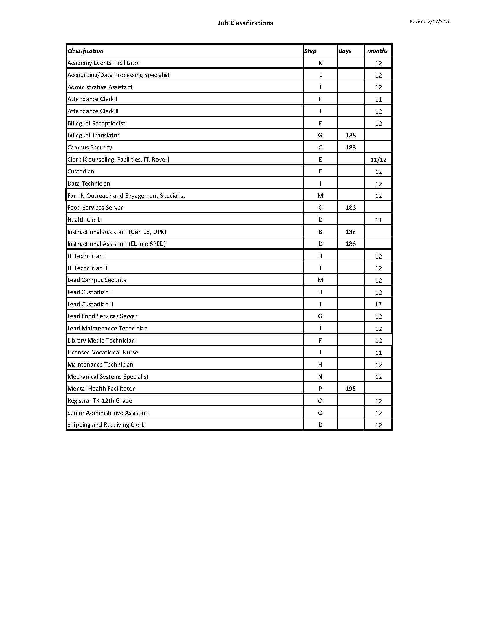
APPENDIX B – GRIEVANCE FORM

APPENDIX C – HEALTH AND BENEFITS PLANS
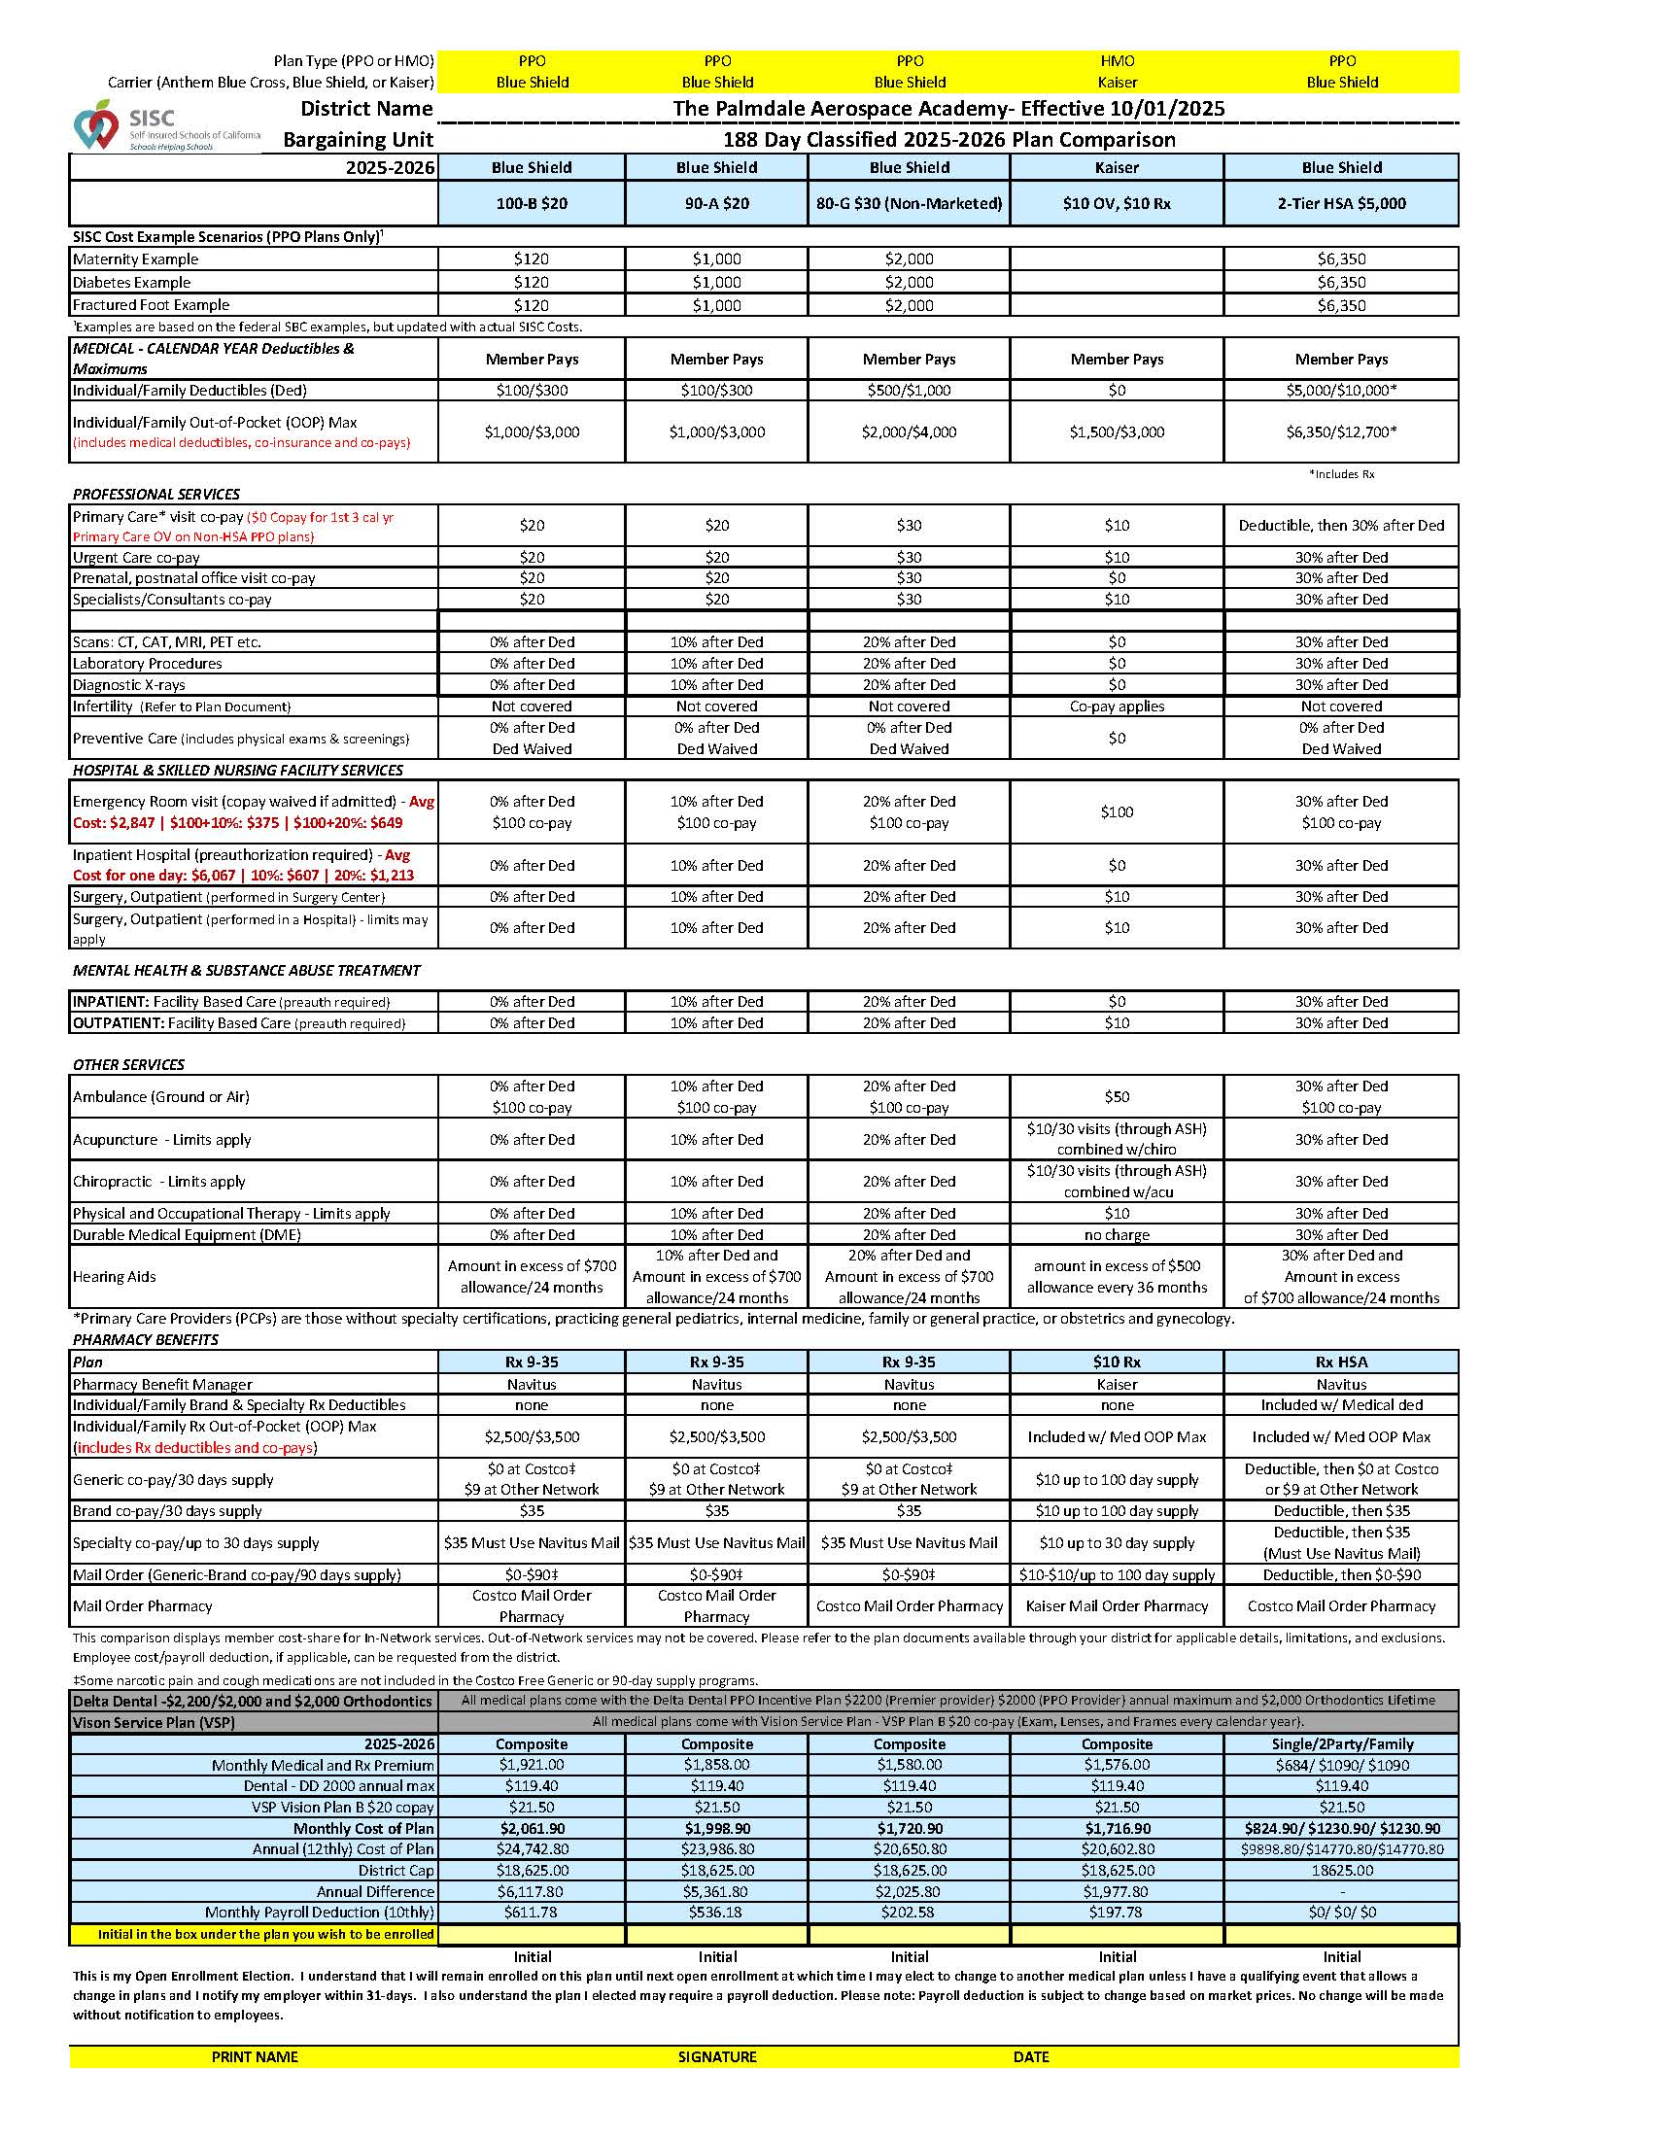
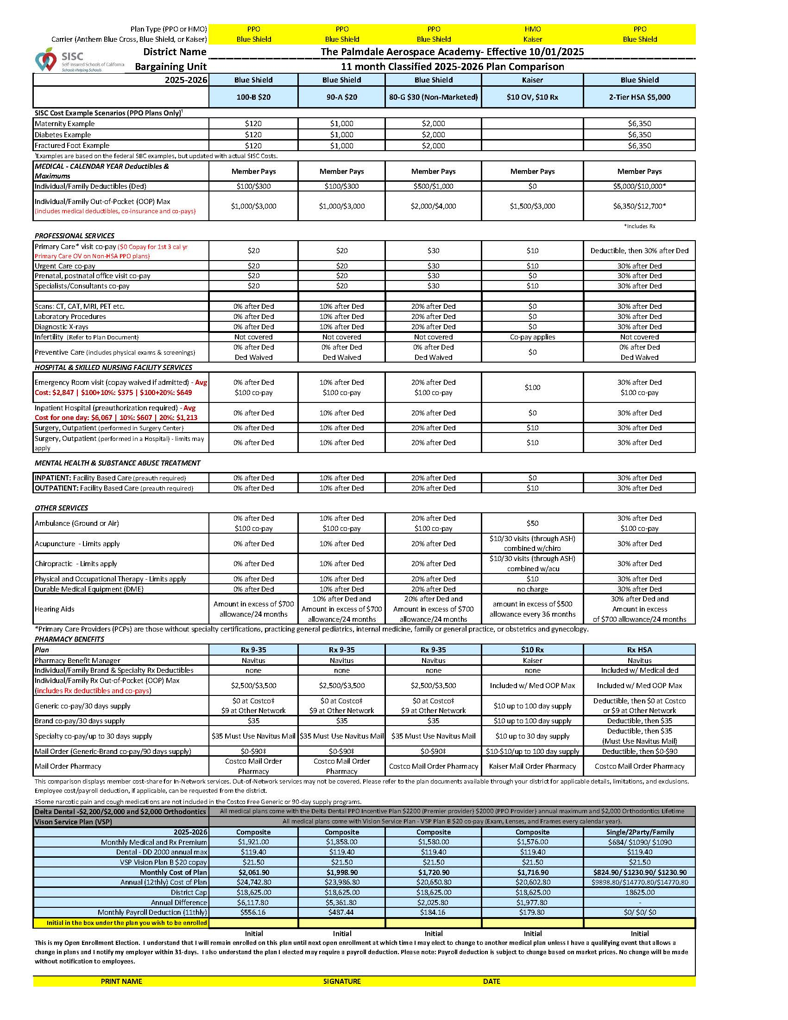

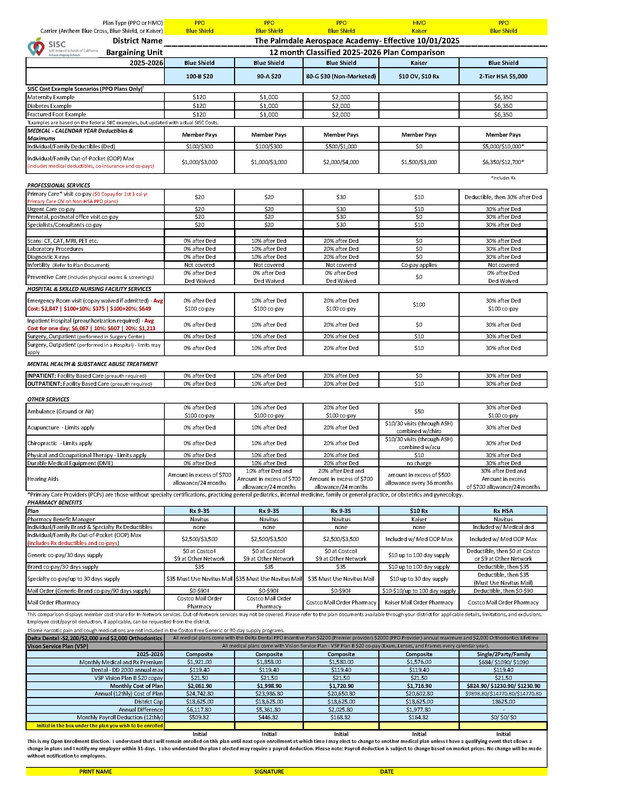

APPENDIX D – SICK LEAVE DONATION FORM
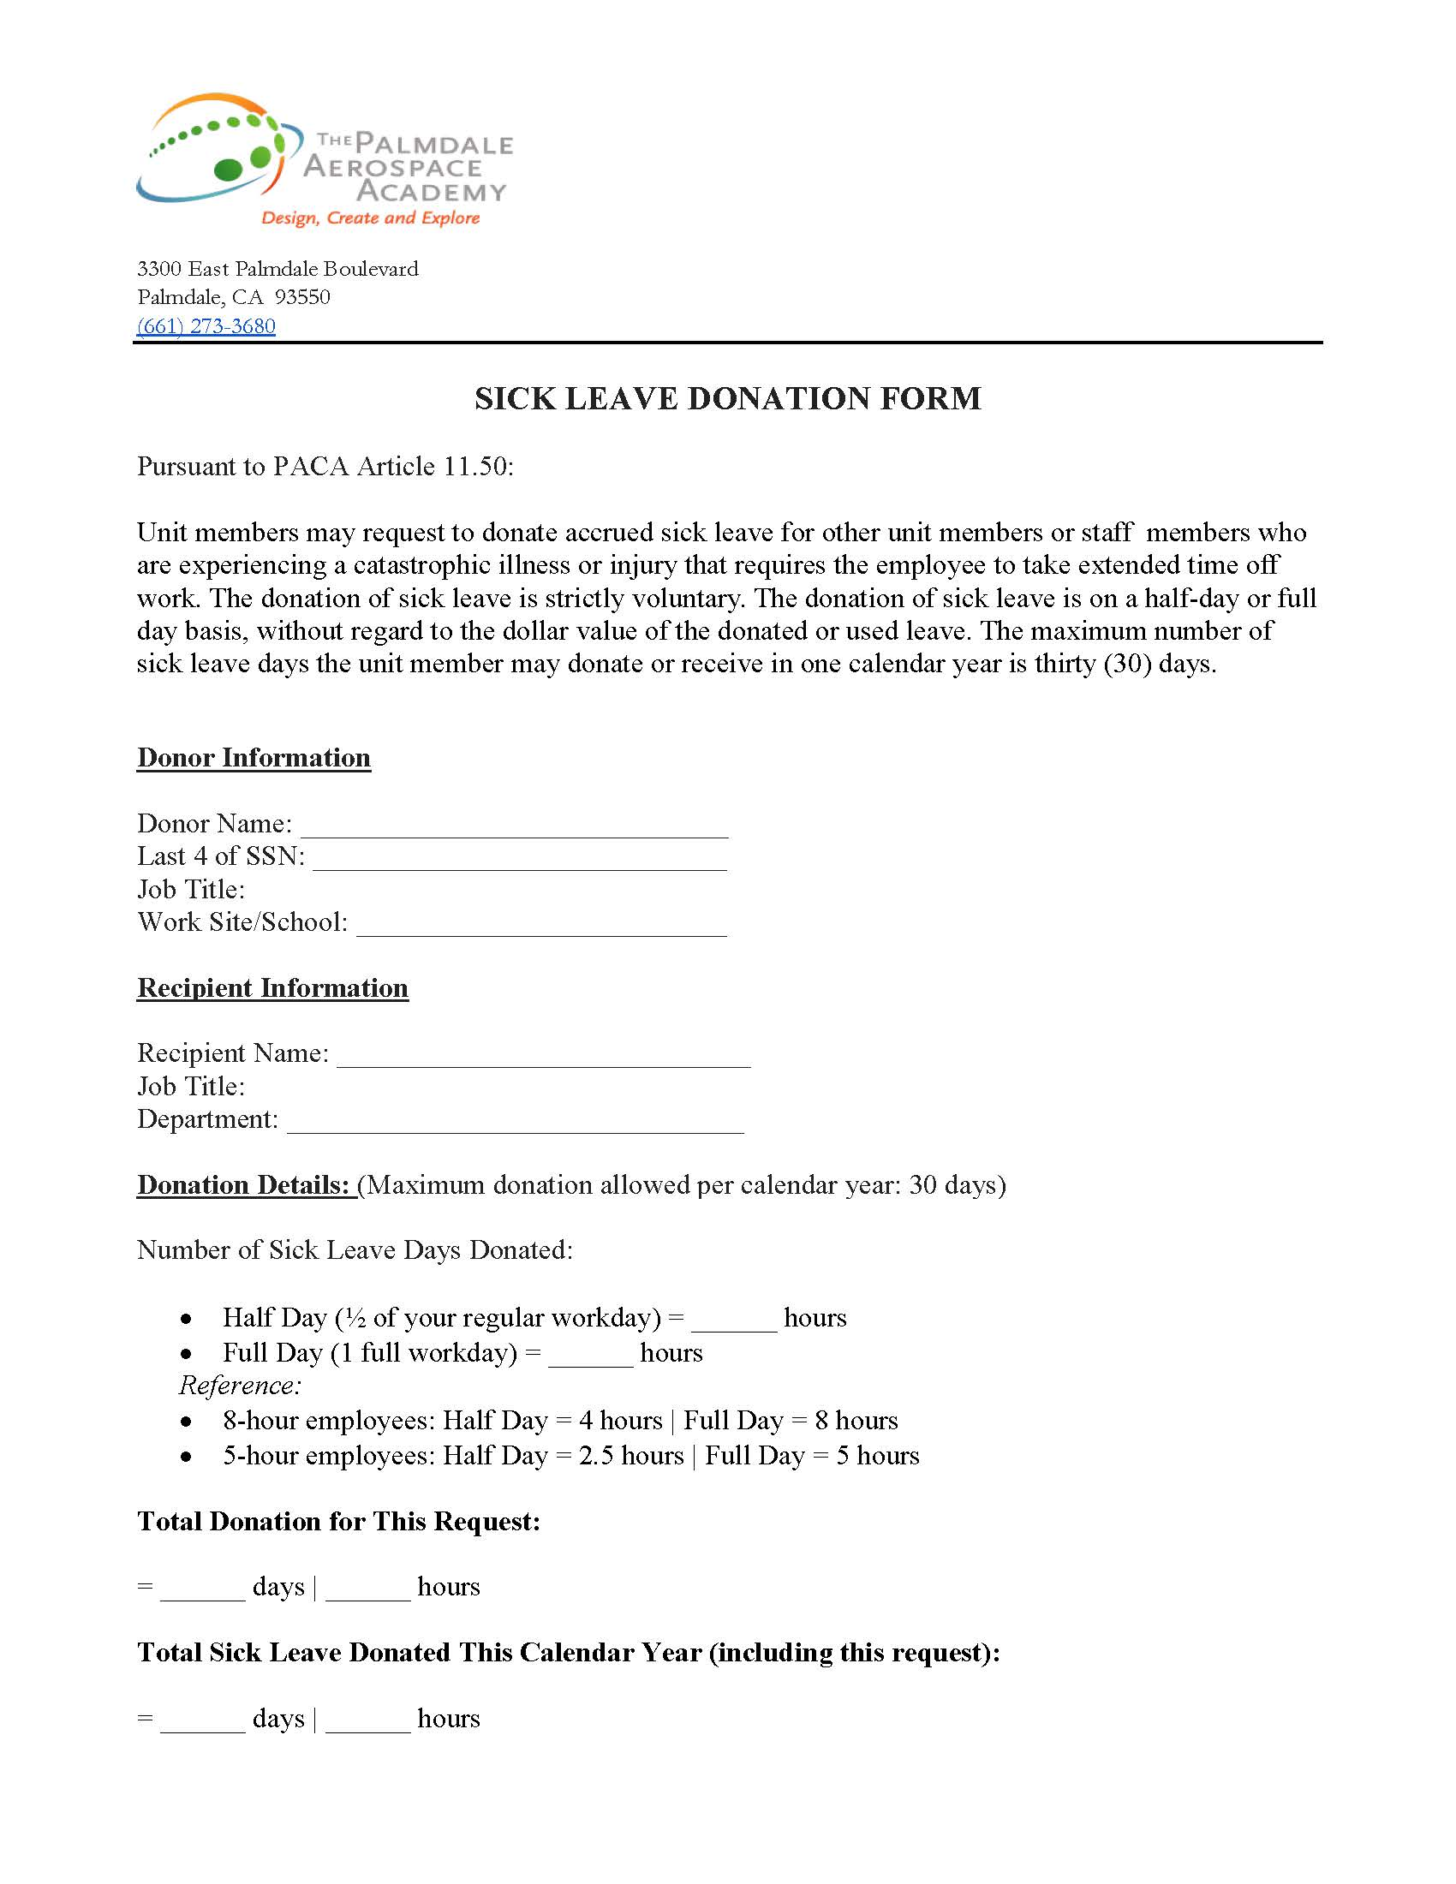
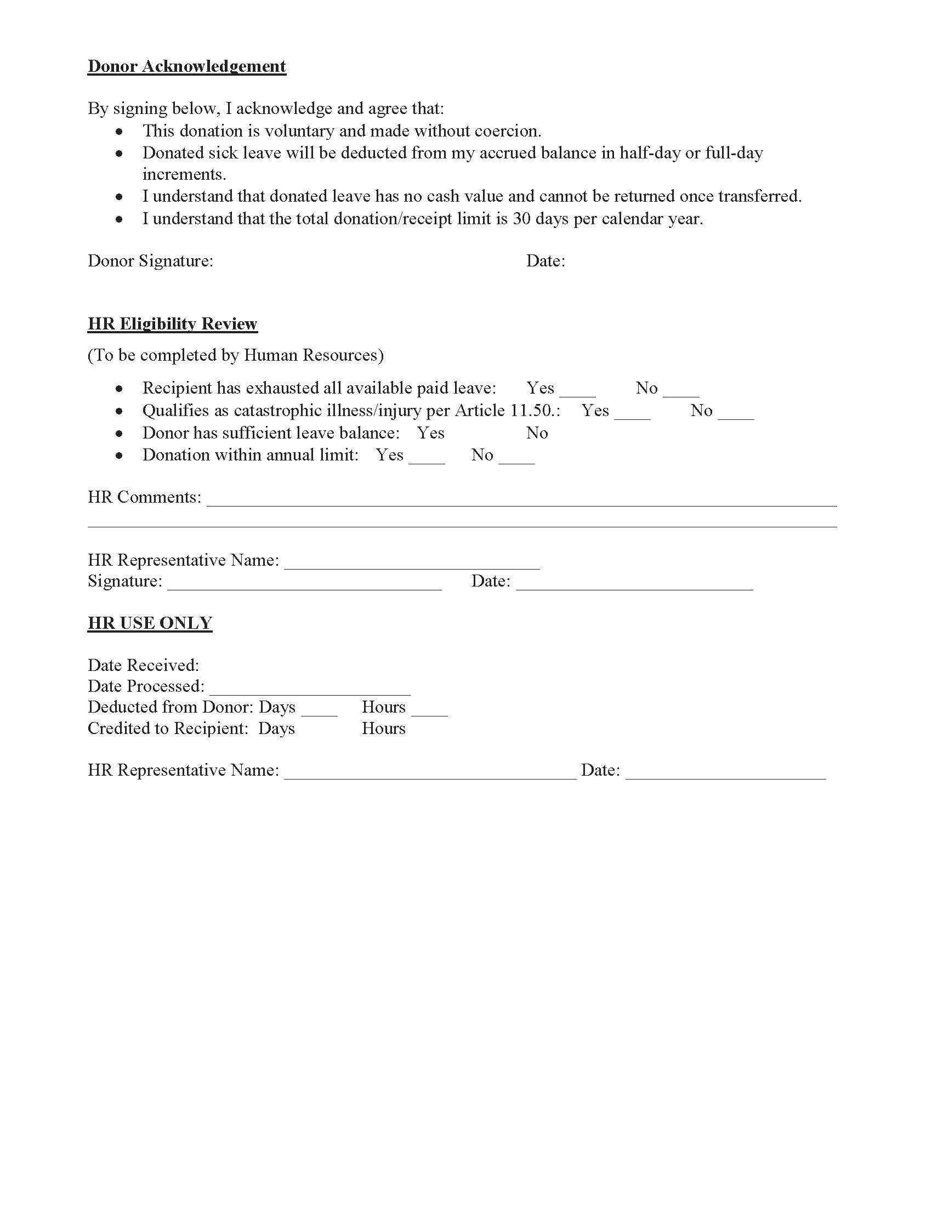

APPENDIX E – WORK YEAR AND HOURS OF EMPLOYMENT
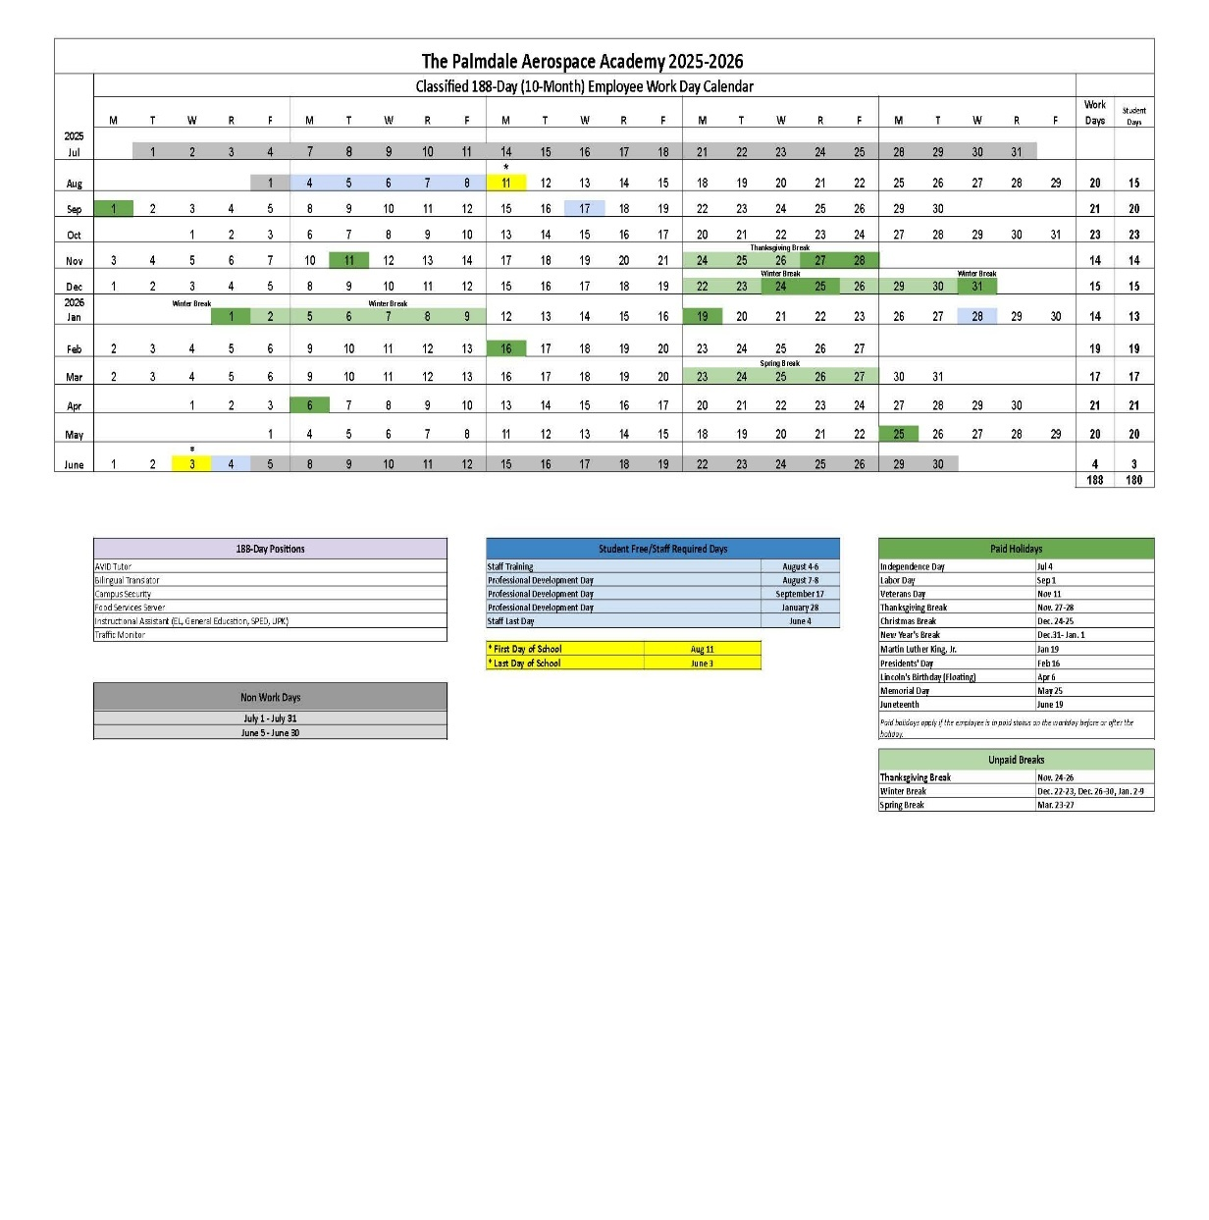
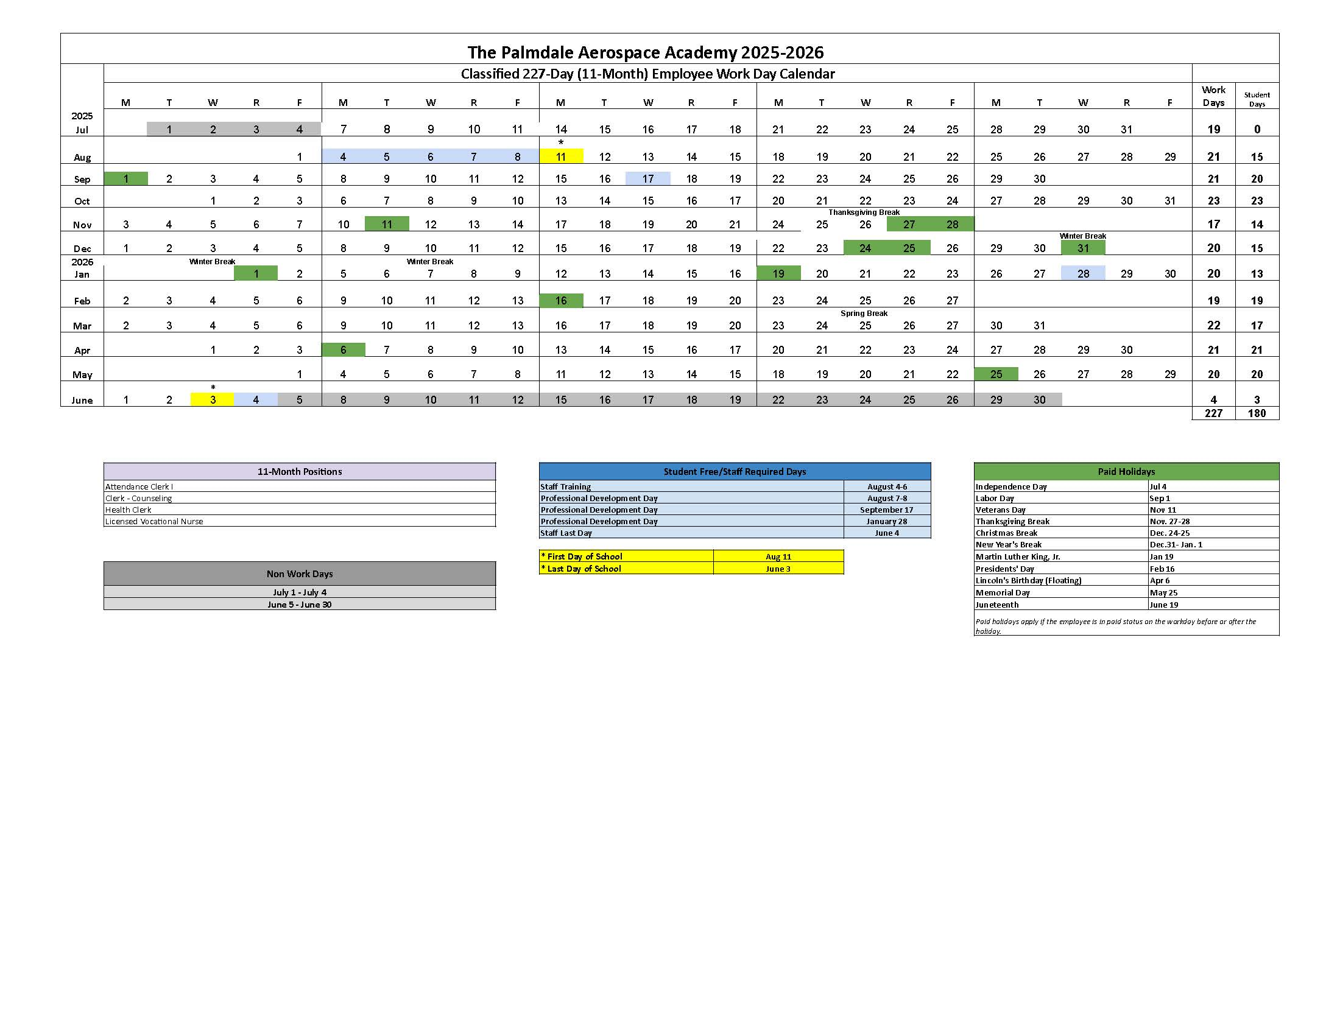
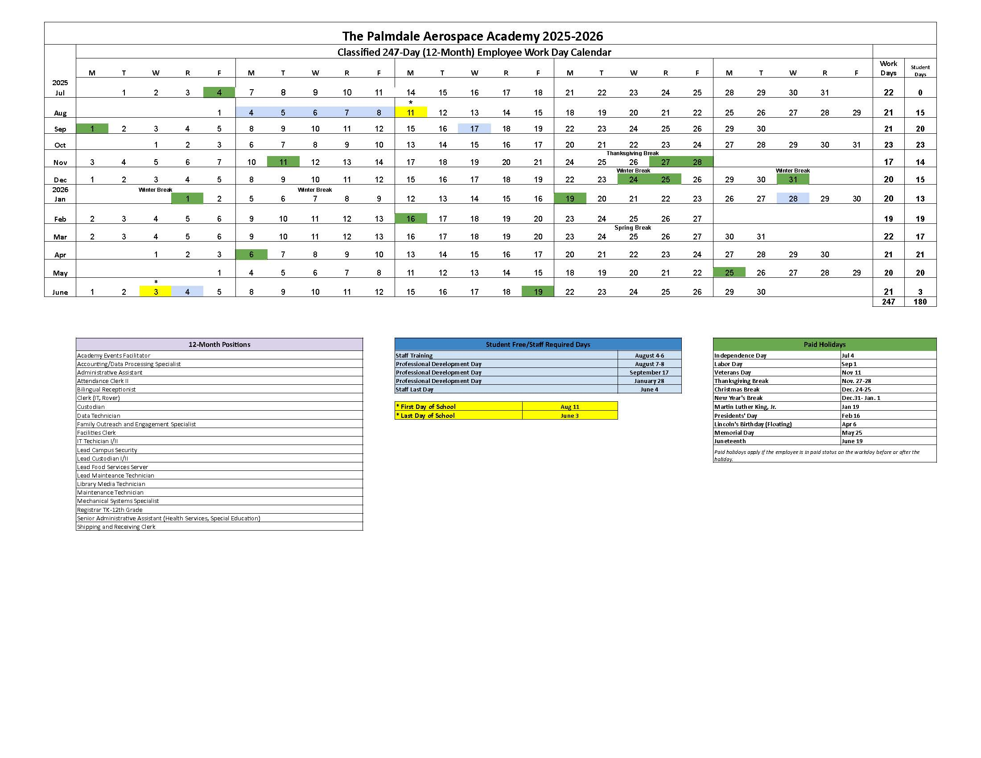

APPENDIX F – EVALUATION FORM
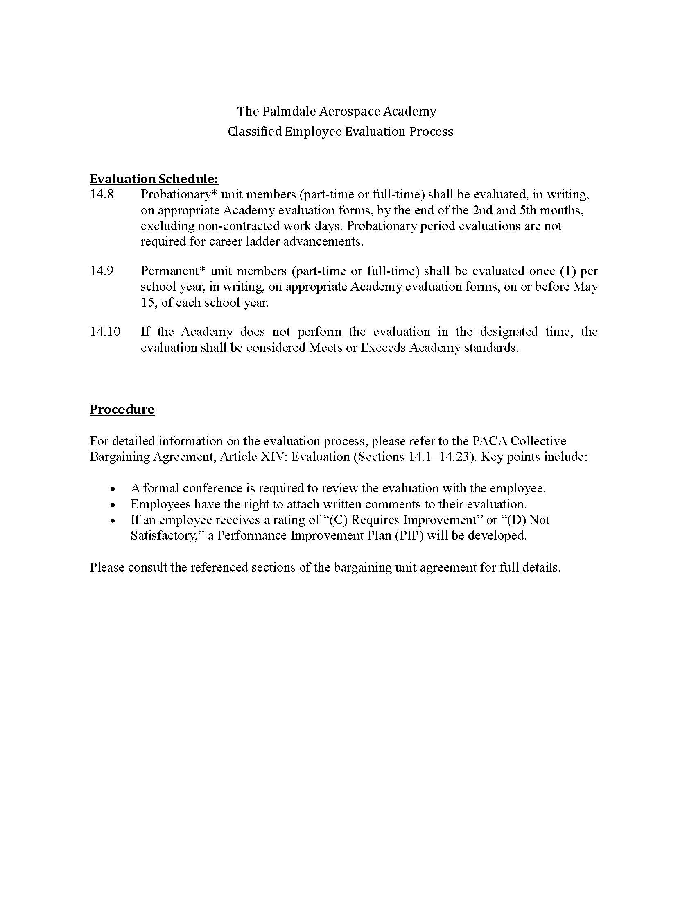
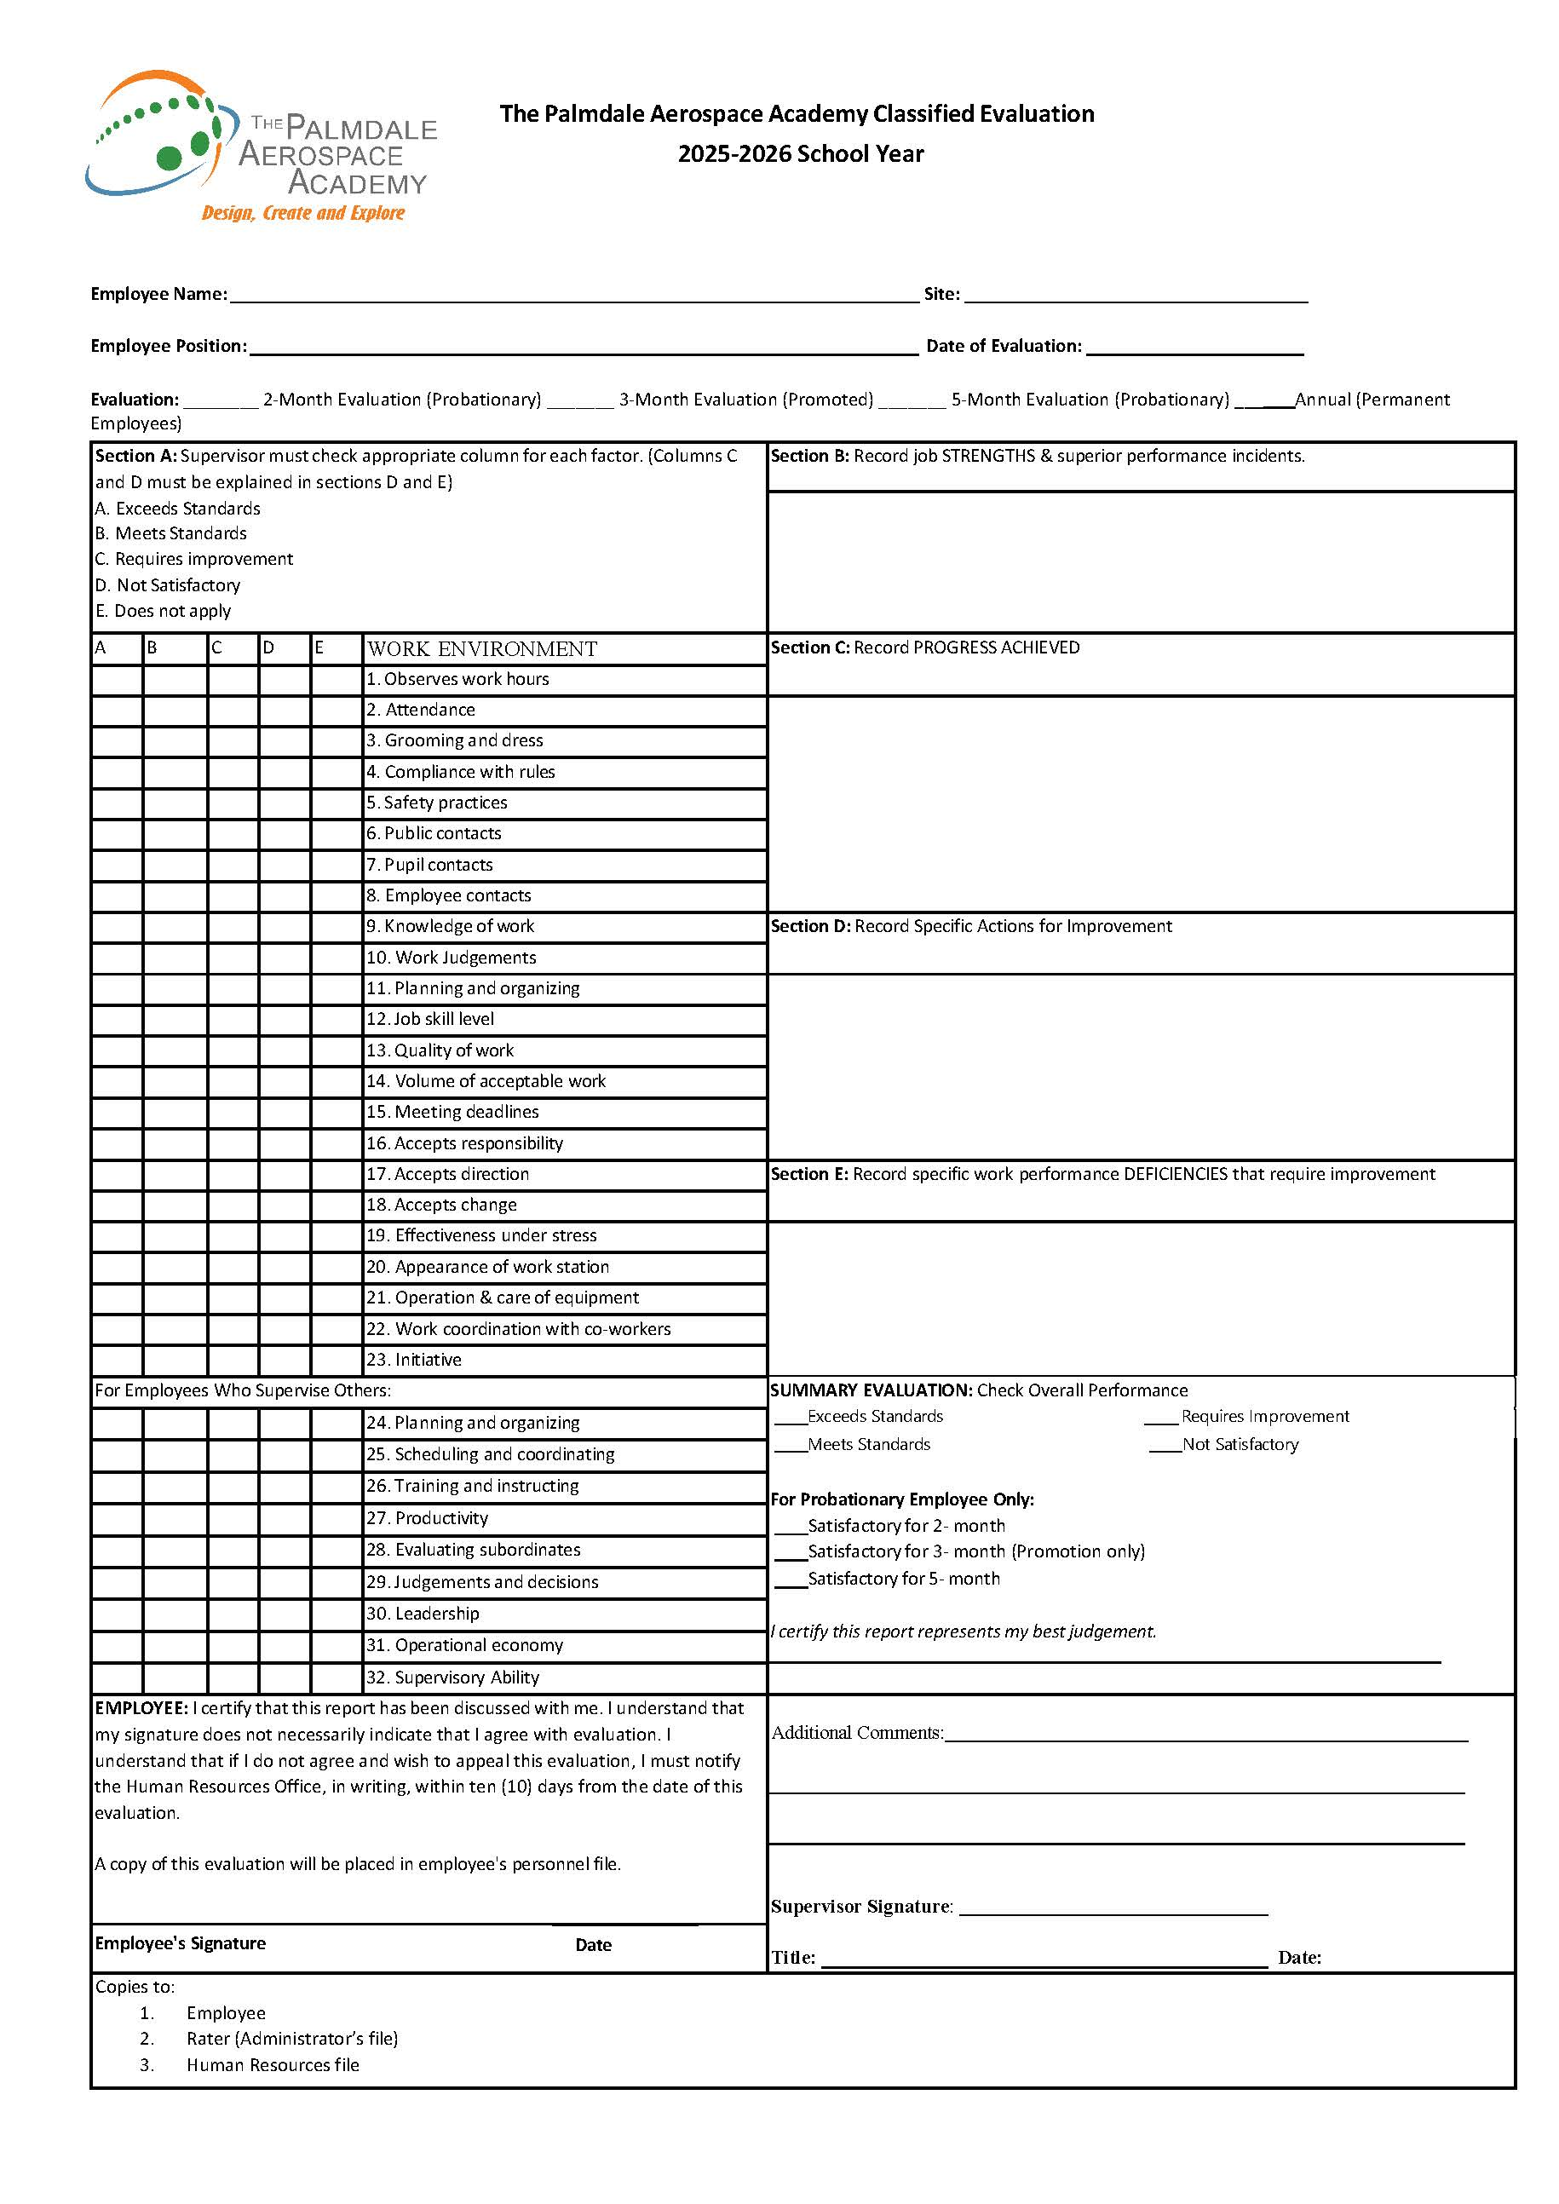

Tentative Agreement
Between
Palmdale Aerospace CLASSIFIED Association
And
The Palmdale Aerospace Academy
JANUARY 27, 2026

aRTICLE – COMPENSATION

Salary Schedule
  - For the 2024-2025 school year, the Academy will pay each classified unit member currently employed and in paid status at the time this Agreement is ratified and approved by both Parties, a one-time, off-schedule payment of $3,000, not prorated, minus required withholdings.
  - Retroactive to July 1, 2025, for the 2025-2026 school year, in addition to the revisions noted in Exhibit A (Classified Support Wage Schedule), the 2024-2025 Classified Support Wage Schedule will be increased by two percent (2%). In addition, all classified unit members shall receive a one-time off schedule payment in an amount equal to two thousand dollars ($2,000), not prorated, minus required withholdings. Classified unit members must be employed with the Academy on the date of ratification by both Parties to receive retroactive pay and the one-time off-schedule payment.
The following columns shall be added to the salary schedule:
· Column 7, with a range percentage increase of 2%
· Column 8, with a range percentage increase of 2%
· Column 9, with a range percentage increase of 2%

Placement on the newly added columns shall not be based on prior years of service or experience. Column advancement shall continue to be limited to one (1) column per year of Academy service, consistent with existing practice. Accordingly, unit members on Column 6 as of June 30, 2025, shall be placed on Column 7 effective April 1, 2026, and shall advance to Column 8 effective July 1, 2027. Thereafter, unit members shall advance only in accordance with the standard annual column progression.
  - Placement on the Classified Support Wage Schedule of each unit member shall be determined by the guidelines outlined in this Article.
  - All unit members shall advance one (1) column on the salary schedule for each year of service, except those whose placement is at the maximum salary schedule column. A year of service for movement is defined as being in paid status for at least 50% of the unit member’s work year calendar.
  - Effective July 1, 2024, newly hired unit members may be given credit for previous related experience at the rate of one (1) column per each year of related experience, and placed on the appropriate higher column, up to and including column 3, upon employment. Such prior service shall meet either of the following criteria:
    - Previous service was rendered at a public, private, or charter school system within the United States of America, Canada, or independent schools maintained for American overseas dependents.
    - Previous service was rendered in a position comparable to the initial assignment, as reasonably determined by the Superintendent or their designee.
  - Column placement of each unit member shall be determined by the guidelines defined in this Article. No unit member shall experience a reduction in compensation as a result of the implementation of this agreement.
  - When a unit member is promoted, the member will be placed on the column closest to their current rate of pay rounded up.
Stipends
  - The following annual stipends are in addition to the unit member’s placement on the salary schedule. The stipend amounts are not cumulative. Payment will be provided at the end of each semester, split into two payments (50% each). Unit members must work the full semester to receive the stipend. Annual stipends. The annual stipends described in this section are paid in addition to a unit member’s placement on the salary schedule. Stipends are not cumulative.
  - Eligibility for a stipend is established upon the unit member: (1) earns the applicable degree and submits required verification to the Academy; and/or (2) attains the applicable longevity benchmark based on their individual hire date.
* The articles listed below will be renumbered once added into the collective bargaining agreement. *
  - Stipends shall be paid in equal installments per pay period. For academic stipends, payment shall begin the first of the month following the month in which the degree is earned and required verification is received by the Academy. For longevity stipends, payment shall begin at the next pay period and be equal to the total stipend amount divided by the number of months left in the applicable school year.
A unit member must be in paid status for the applicable month to receive the stipend payment for that month.
    - Associate Degree $750
    - Bachelor’s Degree $1,000
    - Master’s Degree $2,000
    - Doctorate Degree $3,500
    - 10-year longevity $1,000
    - 15-year longevity $1,250
    - 20-year longevity $1,500
    - 25-year longevity $2,000
    - 30-year longevity $3,000
Pay Warrants
  - Unit members shall be paid on the tenth (10th) of each calendar month and the twenty-fifth (25th) of each calendar month.
    - If the normal pay date falls on a Saturday, Sunday, or Holiday, the warrant shall be issued on the preceding workday.
  - Should any payroll error result in an overpayment to a unit member, the Academy and the unit member shall meet to work out a reasonable repayment plan. Payroll deductions shall be made in accordance with state law.
  - For voluntary payroll deductions, other than Association membership dues, upon appropriate written authorization from the unit member, the Academy shall deduct from the salary of any unit member and make appropriate remittance for a unit member’s 403(b) and 457(b) retirement plans, voluntary life insurance, and LegalShield benefits, as appropriate and authorized by the unit member, or other plans or programs approved by the Academy.
Overtime Requirement
  - Unit members may be required to work overtime as necessary to meet the operational needs of the Academy.
    - When overtime work is required, the Academy will first seek volunteers from unit members within the same classification, and to the extent possible at the same worksite. Volunteers will be solicited in order of seniority, on a rotational basis, ensuring fair distribution of overtime opportunities among unit members.
    - If there are insufficient volunteers to meet overtime requirements, the Academy will first open up the assignment to unit members within the same classification, but at a different worksite.
    - If there are insufficient volunteers, the Academy will assign overtime work to unit members. Overtime shall be assigned as equally as practicable among unit members at each site, within each classification, by reverse order of seniority.
Overtime Compensation
  - The extension of the regular workday or week may occur when necessary to carry on the business of the Academy, with unit members who work less than eight (8) hours receiving regular pay until they have completed eight (8) hours on duty.
  - Unit members shall be compensated for all overtime hours worked in accordance with California overtime compensations requirements, which include:
    - Time and one-half (1.5) the unit member's regular rate of pay for all hours worked in excess of eight (8) hours in any workday.
    - Time and one-half (1.5) the unit member's regular rate of pay for all hours worked in excess of forty (40) hours in any workweek.
    - Time and one-half (1.5) the unit member's regular rate of pay for the first eight (8) hours worked on the seventh (7th) consecutive day of work in a workweek.
    - Time and one-half (1.5) the unit member’s regular rate of pay for a sixth or seventh consecutive workday for employees whose work schedule is more than four (4) hours per day, five (5) days per week; or
    - A seventh (7th) consecutive workday for employees whose work schedule is less than four (4) hours per day, five (5) days per week.
    - Double time and one-half (2.5) the unit member's regular rate of pay for all hours worked in excess of eight (8) hours on the seventh (7th) consecutive day of work in a workweek.
    - Double (2.0) the unit member's regular rate of pay for all hours worked in excess of twelve (12) hours in any workday.
    - Unit members who work less than thirty (30) hours in a workweek are not entitled to seventh-day overtime.
  - Unit members excused from work because of holidays shall be allowed to utilize the time off in paid status as time worked for the purpose of computing the number of hours worked for overtime credit.

ARTICLE - HEALTH & WELFARE
Health Benefits Plan
  - The Academy shall provide all unit members, their eligible dependents, and domestic partners with a health and welfare benefits plan, including dental, vision, and life insurance. The plans shall be listed in Appendix ??. The health and welfare plans offered by the Academy will remain unchanged for 2024-2025 plan year.
  - The Academy shall provide to the Association the final annual renewal rates for the offered Health and Welfare plans within ten (10) workdays of receipt of the renewal rates.
Dental Insurance
  - The Academy shall provide all unit members, their eligible dependents, and domestic partners with a dental plan, including orthodontic coverage. The plan shall be listed in Appendix ??.
Vision Insurance

  - The Academy shall provide all unit members, their eligible dependents, and domestic partners with a vision care plan. The plan shall be listed in Appendix ??.
Life Insurance
  - The Academy will increase provide life insurance and accidental death and dismemberment from $15,000, per unit member, to in the amount of $50,000, per unit member. Any additional increase will be at the unit member’s expense.
Income Protection

  - The Academy will continue to participate in the State Disability Insurance Program (SDI).
  - The Academy shall provide for each unit member Long-term Disability insurance.
Contributions

  - Effective October 1, 2024, the Academy’s maximum contribution to the health and welfare plan shall be $18,625, annually.
  - Full-time unit members are eligible for Academy provided health, dental, vision, and life insurance, as set forth herein.
  - If eligible, an individual part-time employee may opt-in to a qualifying medical plan. The member will be responsible for the full cost of the medical plan.
  - For unit members working a ten-month (10-month) or eleven-month (11-month) period each year, health insurance premiums will be calculated and distributed over the ten (10) or eleven (11) months of active employment. The total annual premium for health insurance will be divided into ten (10) or eleven (11) equal monthly payments, which will be deducted from the employee’s paycheck during the months they are actively employed.
Duration of Benefits

  - Unit members who are employed for an entire school year shall be eligible for benefits under the Academy's benefits program for a full 12-month period. Unit members who are initially employed prior to the fourth day of the month shall be eligible for coverage from their first day of active employment beginning that month. Unit members hired after the third day of the month, will be eligible for coverage on the first day of the following month.
  - Unit members who terminate their employment prior to the close of the work year shall be provided benefits through the last day of the month in which the termination occurred.
  - Any Unit Member on a paid leave of absence shall be eligible to receive the medical, dental, and vision insurance coverage provided by the Academy consistent with the terms of this Article.
  - Any Unit Member on an unpaid leave of absence shall be eligible to continue to participate in the medical, dental, or vision program available generally to bargaining Unit Members. Participation shall be at the Unit Member's expense and is conditioned upon a willingness of the carrier to extend such coverage.
Employee Assistance Program Plan

  - The Employer shall provide unit members and their eligible dependents, including domestic partners and their dependents, access to an employee assistance program plan.
  - Unit member participation in the employee assistance plan shall be entirely voluntary and shall be kept confidential. The Employer shall not use any information about a unit member gathered as a result of their participation in the employee assistance plan for any evaluation, discipline or dismissal procedure.
  - A unit member's decision to participate or not to participate in the employee assistance plan shall not in itself jeopardize any right to which the member is otherwise entitled.
IRC 125 Plan and Health Reimbursement Accounts

  - The Academy will offer a Flexible Spending Account (FSA -IRC 125 Plan).
  - The IRC 125 plan shall allow a unit member to expense certain benefits provided by the plan on a pretax basis. The following voluntary programs shall be offered, and unit members may participate in any or all by contributing, through payroll deduction, the actual cost of these programs:
    - Qualifying medical expenses
    - Child Care
  - The Academy shall pay the fees associated with the general administration of the IRC 125 Plan
Miscellaneous Provisions

  - All full-time unit members must enroll in a health, dental and vision plan.
  - In the case of bargaining unit members who are married or are registered domestic partners, the Academy will provide insurance to each individual unit member.
  - The Academy will provide information on Health and Welfare Benefits for all new hires and other unit members upon request.
Health Benefits Committee

  - The Academy and the Association are committed to maintaining a quality health and welfare program. The parties agree to a good faith effort and commitment to maintain a program, which is comprehensive and cost-effective. A Health Benefits Committee will be formed in an effort to analyze, understand, and reduce costs, and shall meet on a regular basis. The Health Benefits Committee shall be comprised of up to nine (9) representatives; three (3) each from the Association, PATA, and The Academy, selected by their respective groups. No other employee group will have more than three (3) representatives.
  - The responsibility of the Health Benefits Committee is to review the cost trends in the jointly selected carriers, program structure, and the benefit plans. The Health Benefits Committee shall have the authority to analyze how the current carriers, program structures, and benefit plans are impacting costs, and to explore options which may reduce costs or rates of increase in costs.
  - All relevant information requested by the Committee that pertains to the Committee's responsibility shall be provided within a reasonable time frame and shared directly with the Committee. This Committee is an advisory body only and any changes recommended shall be forwarded to the respective bargaining teams.
  - Committee members will receive training on effective health and welfare committee work [for example, CHECHER or something similar].

ARTICLE – PROFESSIONAL GROWTH & DEVELOPMENT
  - Participation in professional growth/development opportunities is open to all unit members.
  - To promote successful professional growth/development, the process of content selection for professional growth and development shall include an opportunity for unit members to provide meaningful input and feedback to the Director of Educational Services or designee. Curriculum and Instruction, at least, thirty (30) days in advance of the scheduled professional development day.
    - The Academy will send out a survey to unit members at least once a year, asking for feedback and input on possible training opportunities. The results of the survey will be shared with the Association President or designee, when requested.
  - The work year for bargaining unit members shall include four (4) pupil free professional development days. To provide an opportunity for unit members to attend professional development, the work day on professional development days will be from 7:30 a.m. to 4:00 p.m. Every part time bargaining unit member will be offered the opportunity to work the full day, with additional compensation, however the unit member will only be required to work their regular number of hours.
  - For any professional growth/development that is required which is scheduled outside of the contracted working day (such as on a Saturday, Sunday, or on an otherwise non-contracted work day), the unit member shall receive pay for the time involved at the unit member’s hourly rate. Participation outside the work hours will be voluntary.
  - For any professional growth/development which extends beyond the contracted working day, the unit members shall receive pay for the extra time involved at the unit member’s appropriate hourly rate. Participation outside the work hours will be voluntary.
  - At its sole discretion, the Academy may add additional voluntary (non-mandatory) professional development days, per year, including professional development during the summer, to be paid at the unit member’s appropriate hourly rate.
  - The Academy will provide time to unit members during the work day for mandated training (e.g. Sexual Harassment Training, Pest Control, etc.)
  - The Academy agrees to cover expenses incurred as a result of off-campus training, if such training is required by the Academy. The following expenses shall be covered:
    - Tuition and/or registration fees;
    - Cost of course-required books and materials;
    - Transportation or mileage expenses;
    - Toll and parking fees;
    - Lodging and meal expenses.

This tentative agreement is subject to ratification by both the Palmdale Aerospace Classified Association/CTA/NEA and The Palmdale Aerospace Academy.

Christine Castellanos  Bargaining Chair  Palmdale Aerospace Classified Association | Paul Dilger  Director of Facilities, Maintenance and Operations  The Palmdale Aerospace Academy

